**Tasks on Monitoring**

1. **Title: Enable CloudTrail monitoring and store the events in s3 and CloudWatch log events.**

**objective:** To configure AWS CloudTrail for centralized logging by securely storing audit logs in Amazon S3 and enabling real-time monitoring through Amazon CloudWatch Logs.

**Prerequisites**:

AWS console

cloud trail

cloud watch

s3

IAM

**step by step implementation:**first go to AWS console and go to cloud trail and click on create trail

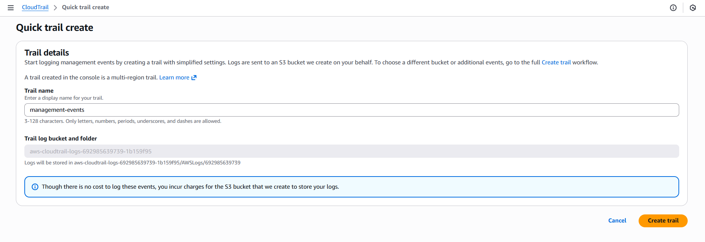

now the cloud trail has been created

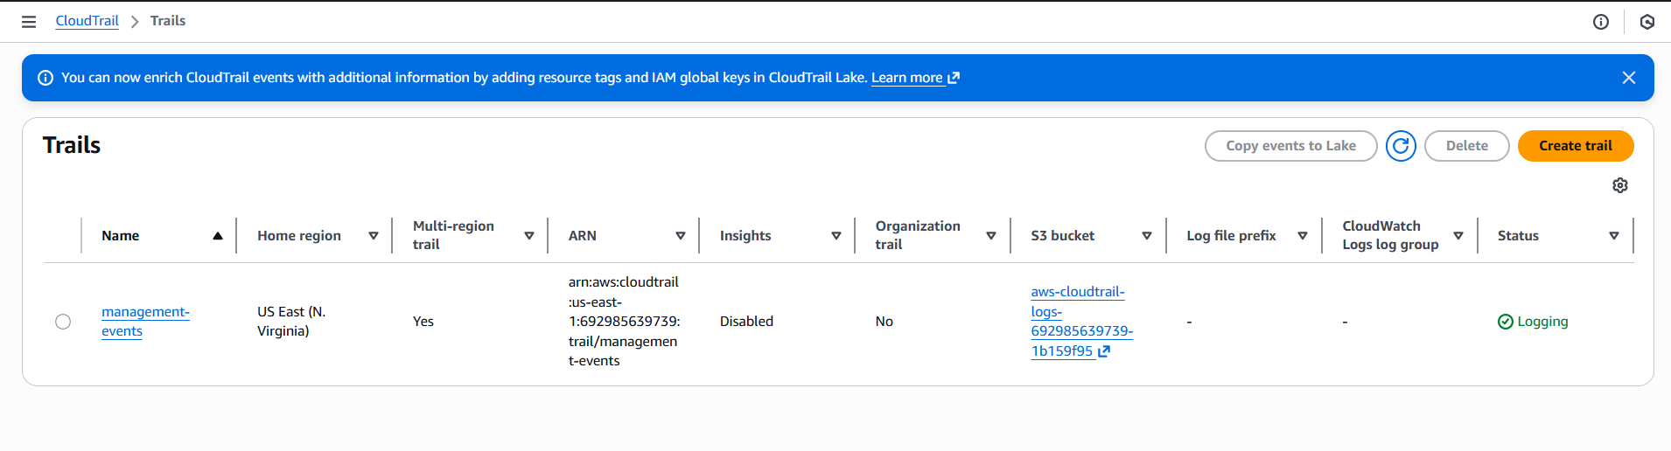

now to go CloudWatch logs and click on edit

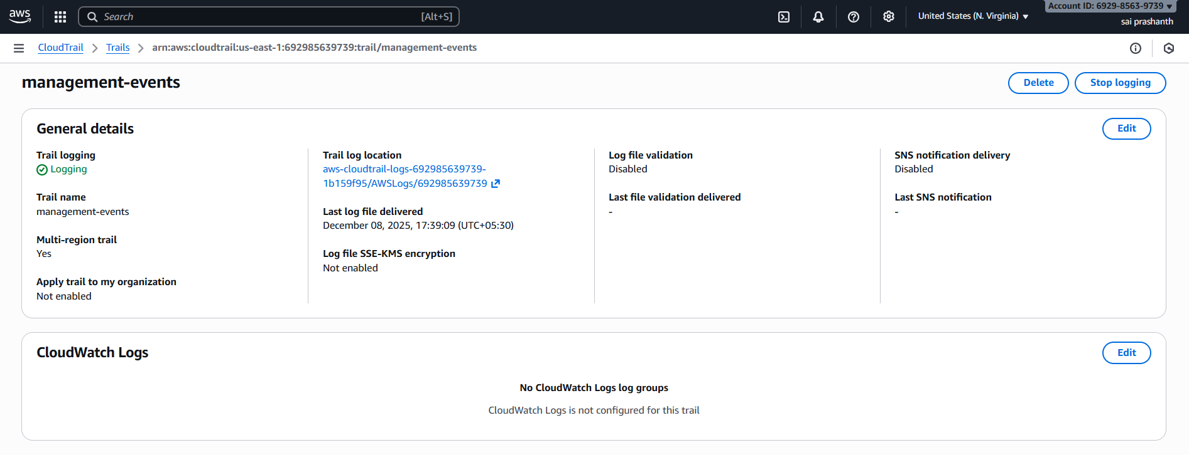

now enable cloud watch logs and give one role name and click on save

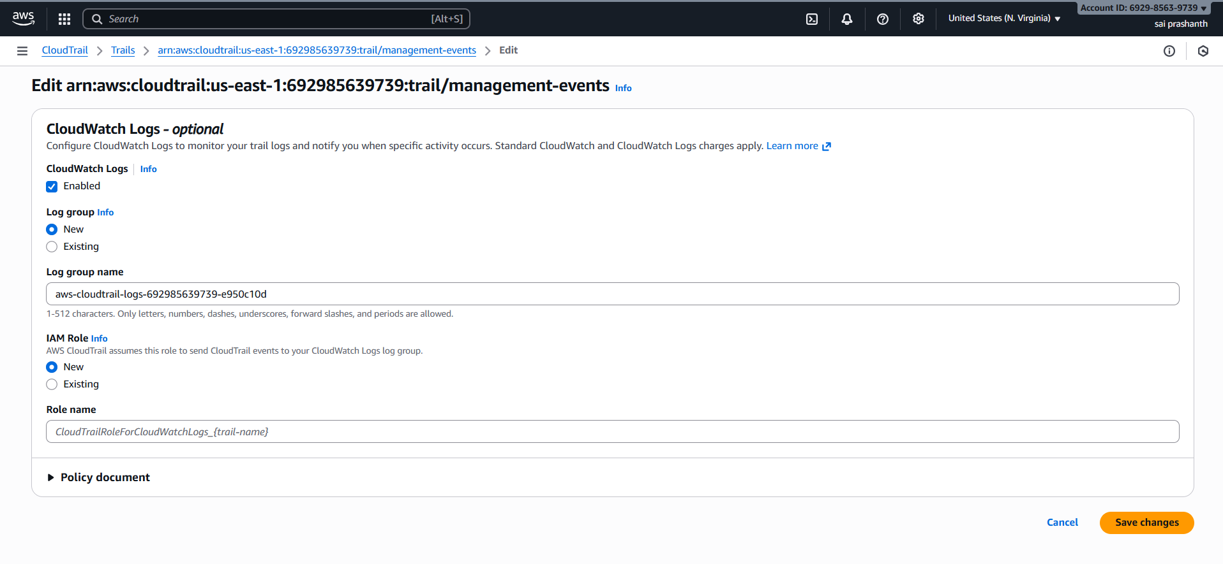

once it has been saved—go to cloud watch—log management to see the logs

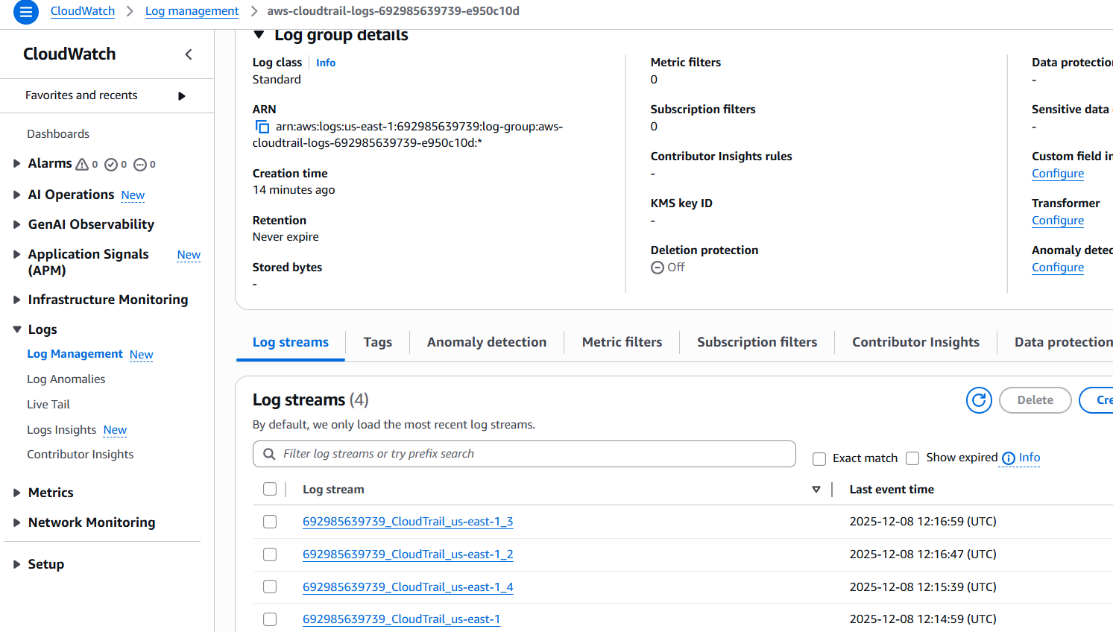

now click on anyone of the log stream to see the logs

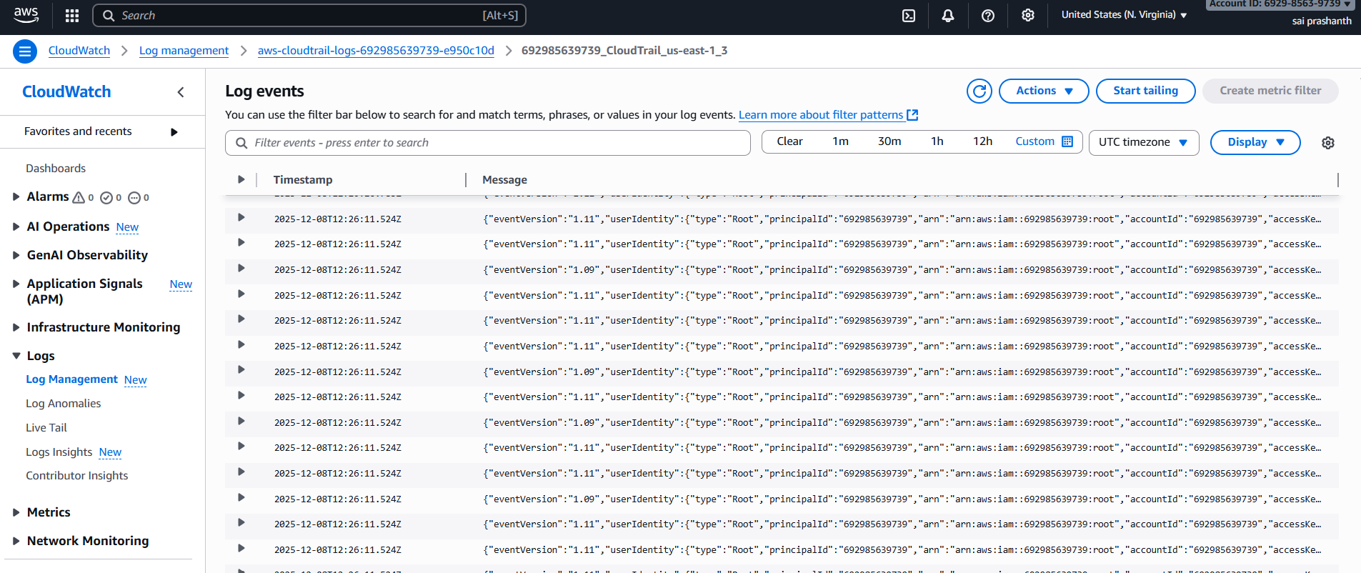

**validation steps:**

now we need to check in S3

go to S3 you can see the logs bucket has been created

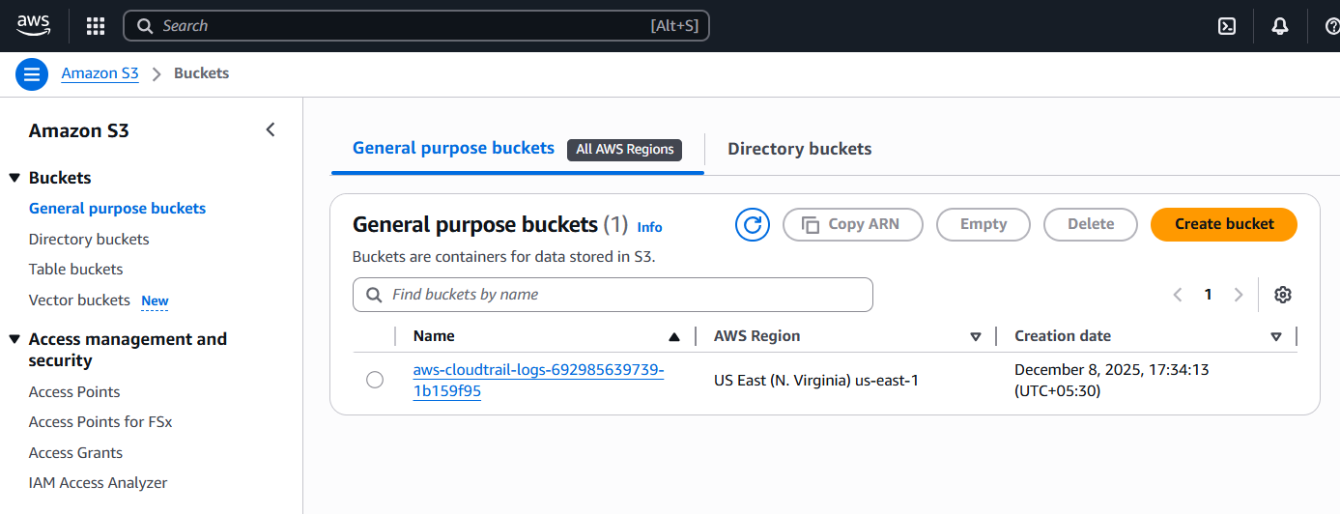

now click on tht logs bucket until u see the name cloudwatch name inside

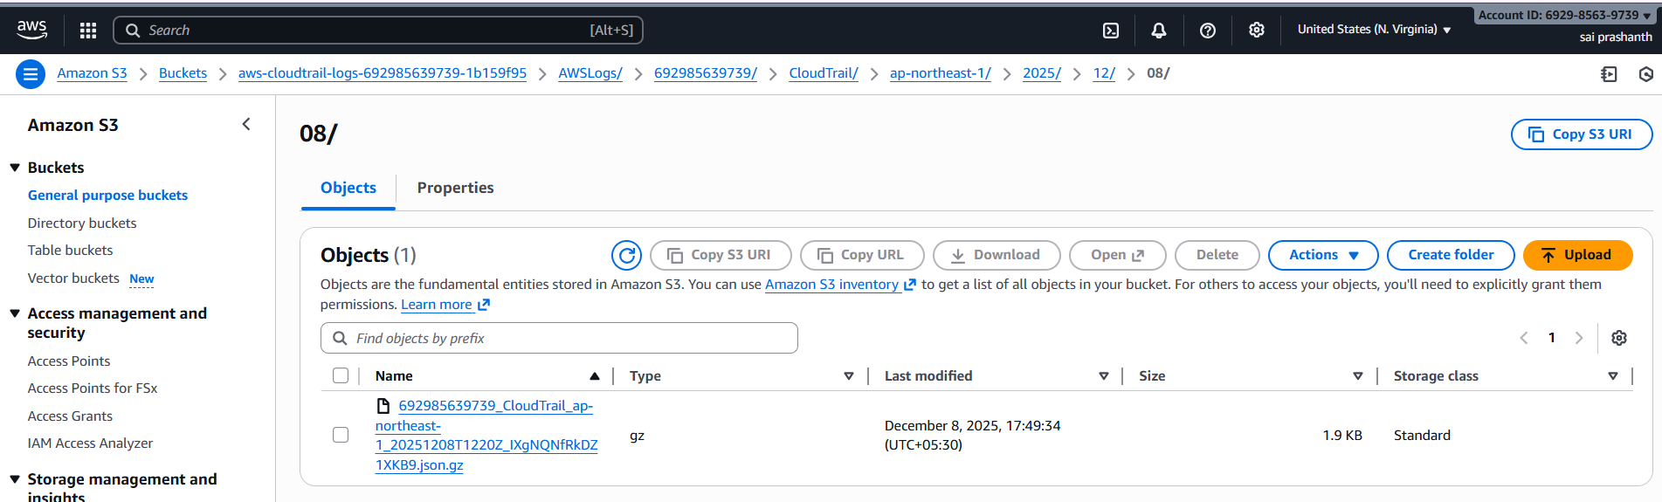

now you can see the url has been created once youo click on that

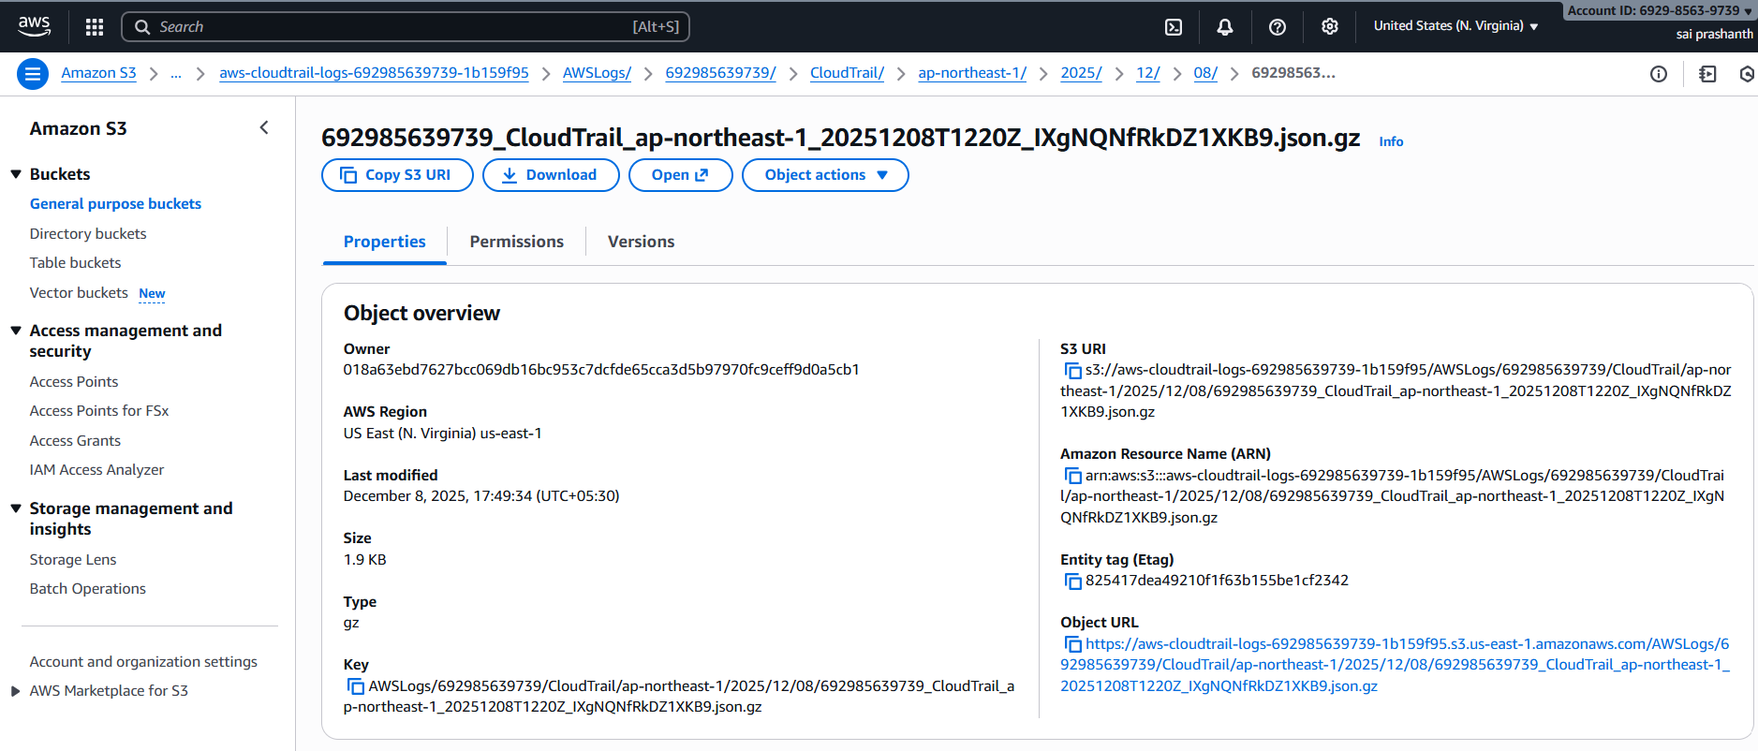

now it is in private to open it click on that open button

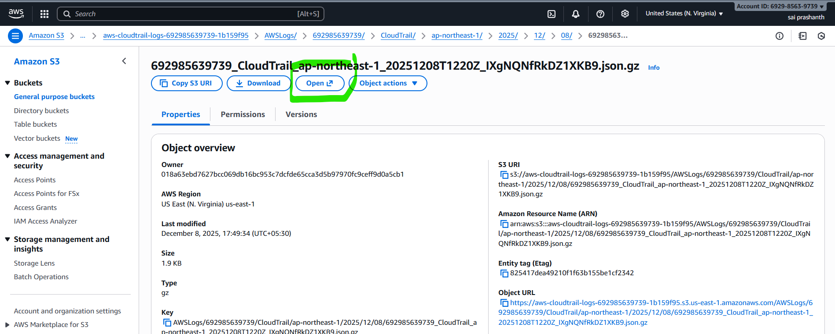

now you can see the it in public once you clicked on that open button

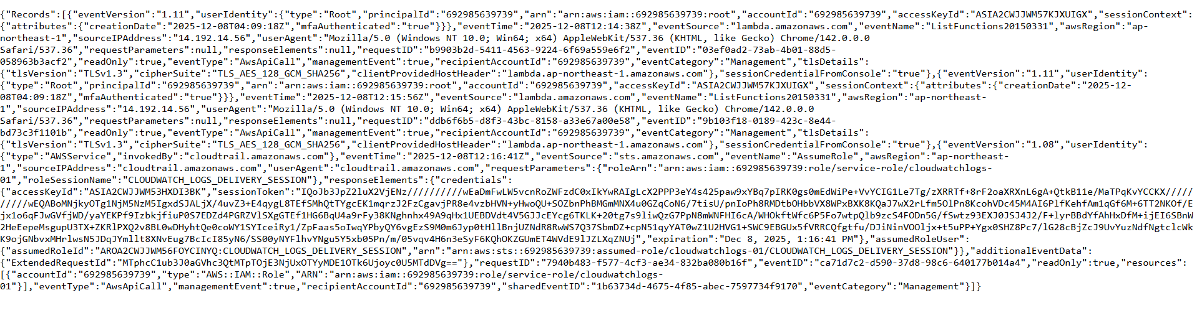

**error**:

after getting this url I have directly clicked on that url

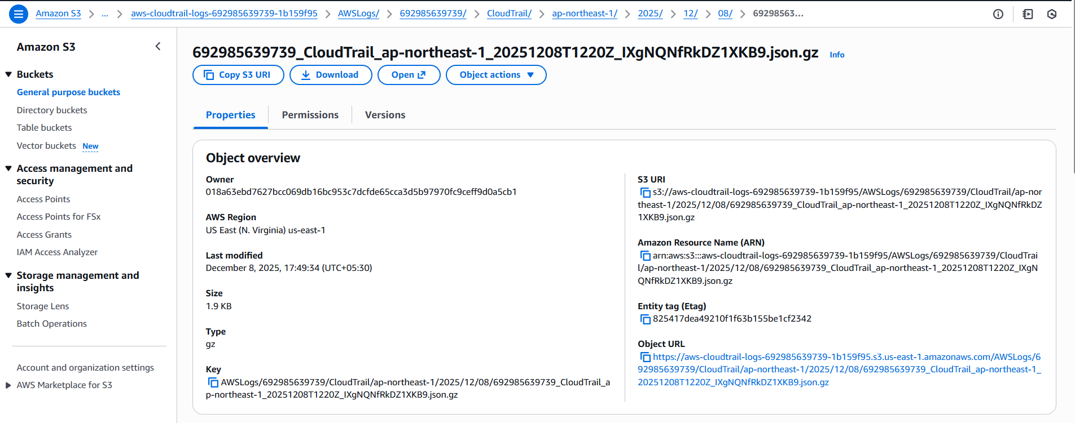

it displayed like cannot open as it is private

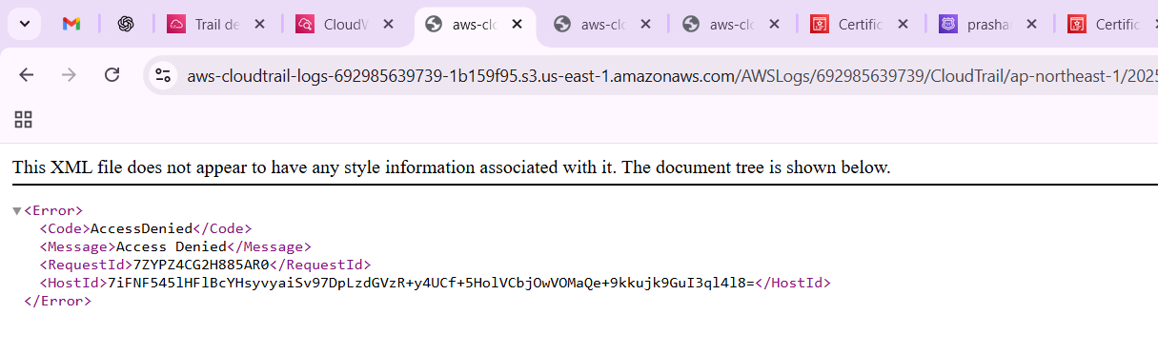

**conclusion**:

now the logs have been stored in S3 and in cloud watch logs.

1. **Title: Enable SNS for cloud trial to send alert on email.**

**objective**: we need to enable SNS for cloud trail to receive an alert to our email

**prerequisites**:

cloud trail

to provide email id

SNS

**step by step process:**

first to cloud trail----select the trail which you have been already created

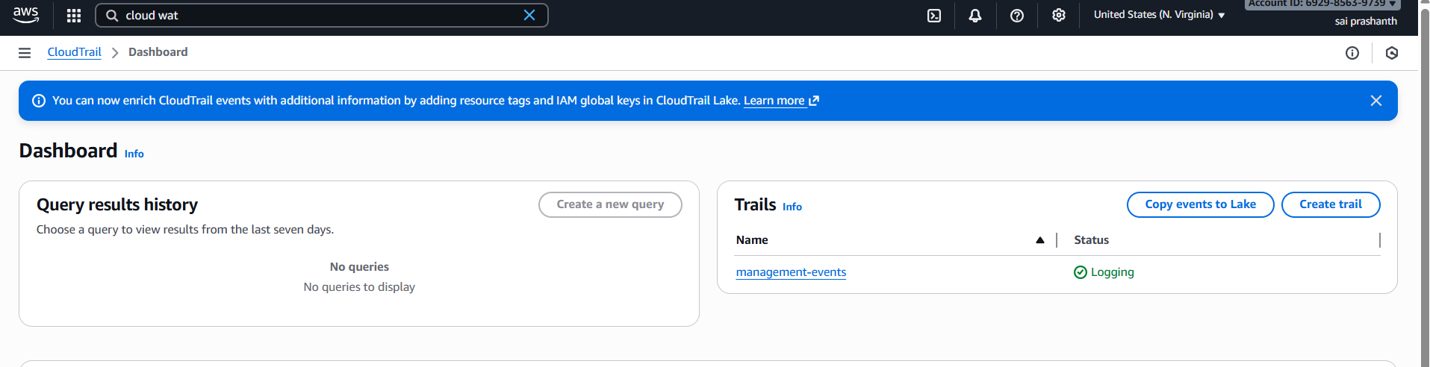

now click on the trail and click on edit to give SNS

now go to additional settings—enable the SNS—and topic has been added by default

and click on save changes

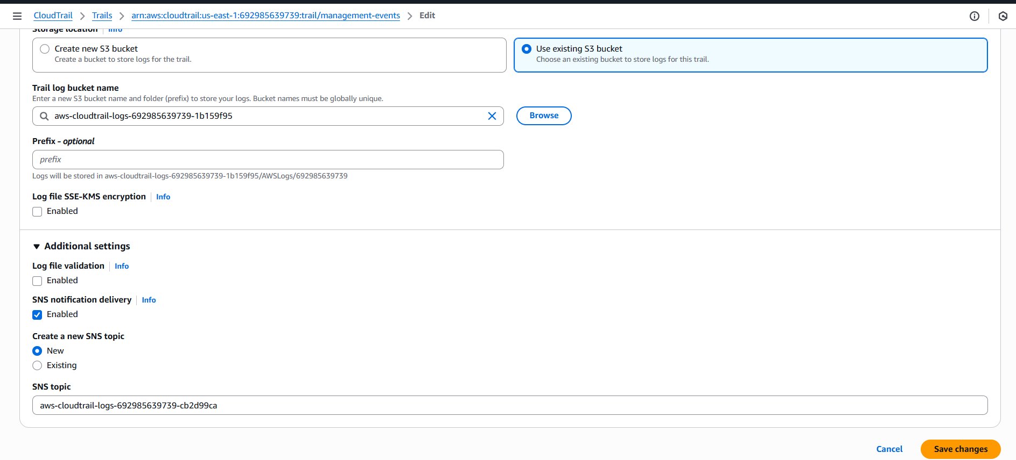

now the SNS has been verified

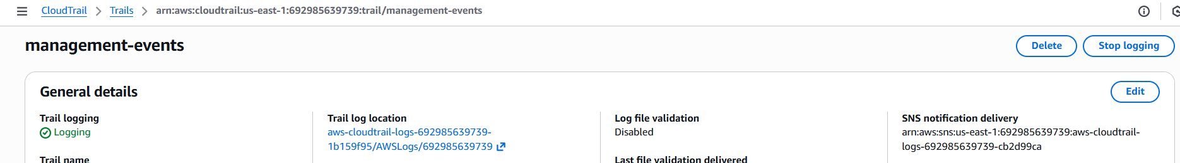

now go to AWS SNS

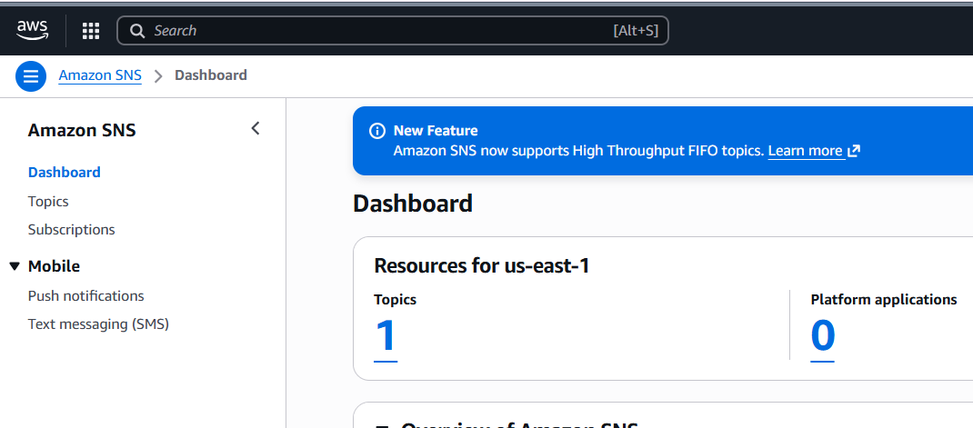

click on the topic and now click on create subscription

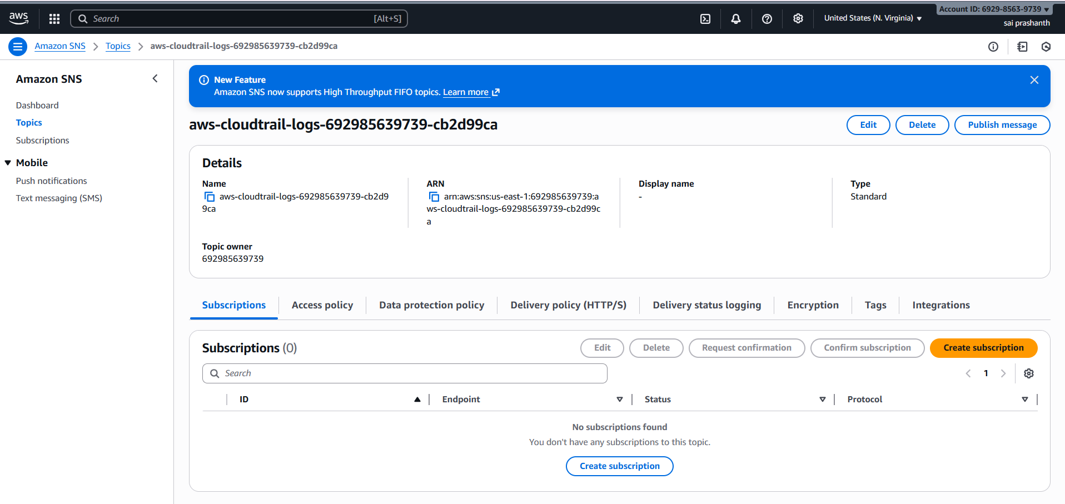

now you need to add email id

add the protocol-email

in end pint tab provide your email id and click on create subscription

you email has been added successfully

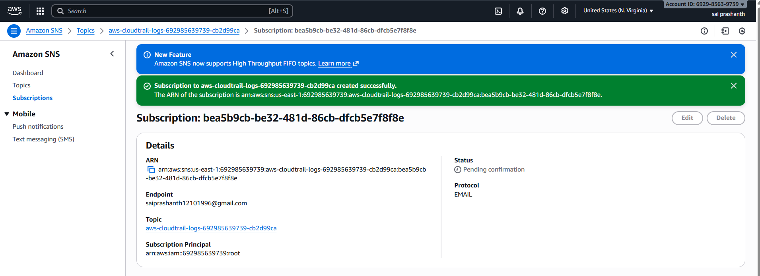

**validation steps:**

now to verify the email

login with your email which you have been provided

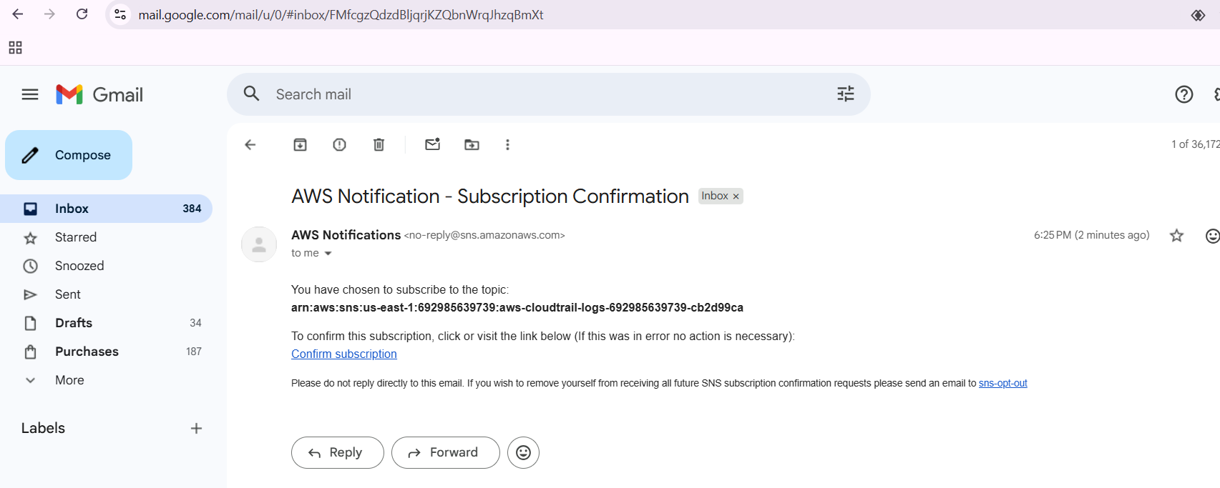

your subscription has been saucerful

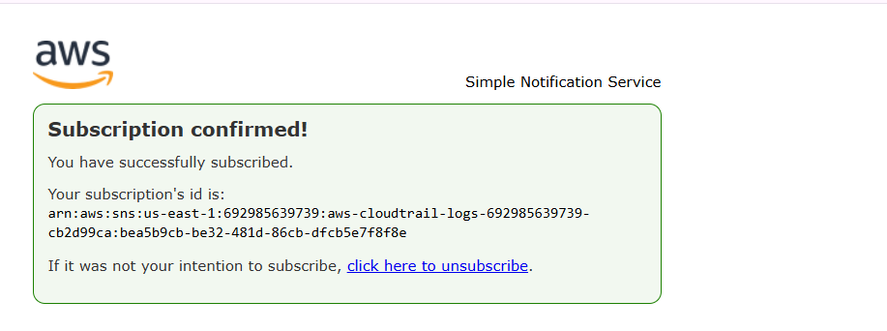

**conclusion**:

By giving you email you can get the notifications or alerts regarding AWS activities

1. **Title: Configure cloud watch monitoring and record the CPU utilization and other metrics of ec2.**

**objective:** we need to configure cloud watch monitoring to record CPU utilization and to capture the metrics

**prerequisites**

cloud watch and ec2

**step by step process:**

first go to aws console

launch one ec2 instance

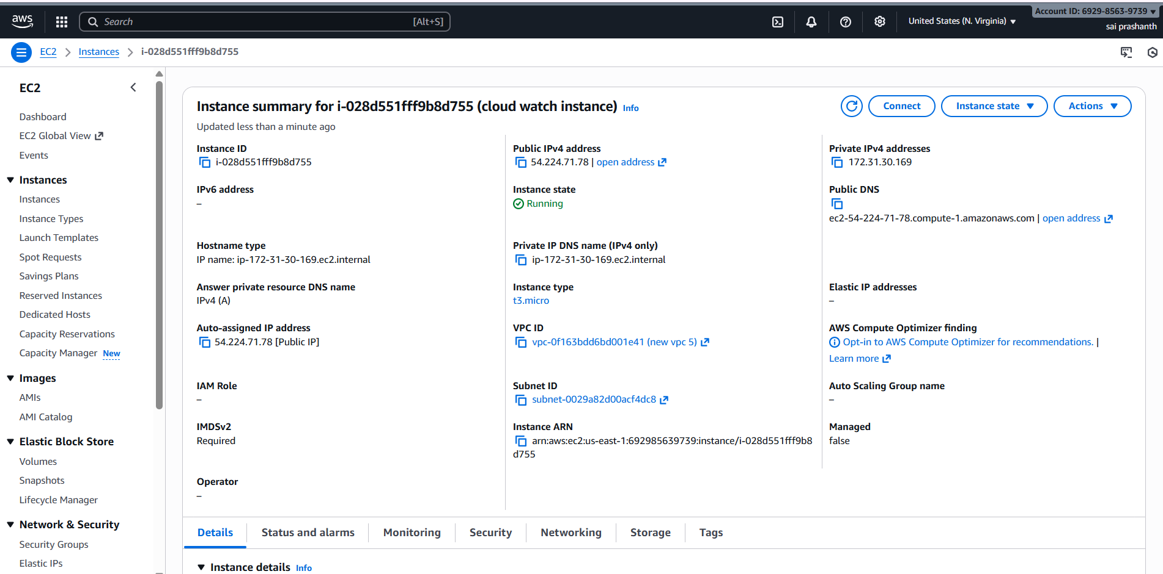

now go to cloud watch---select the metrics

after clicking all metrics---select ec2 you can see on the page and search for cpu utization—if it didn’t get check with cpu only you can find it

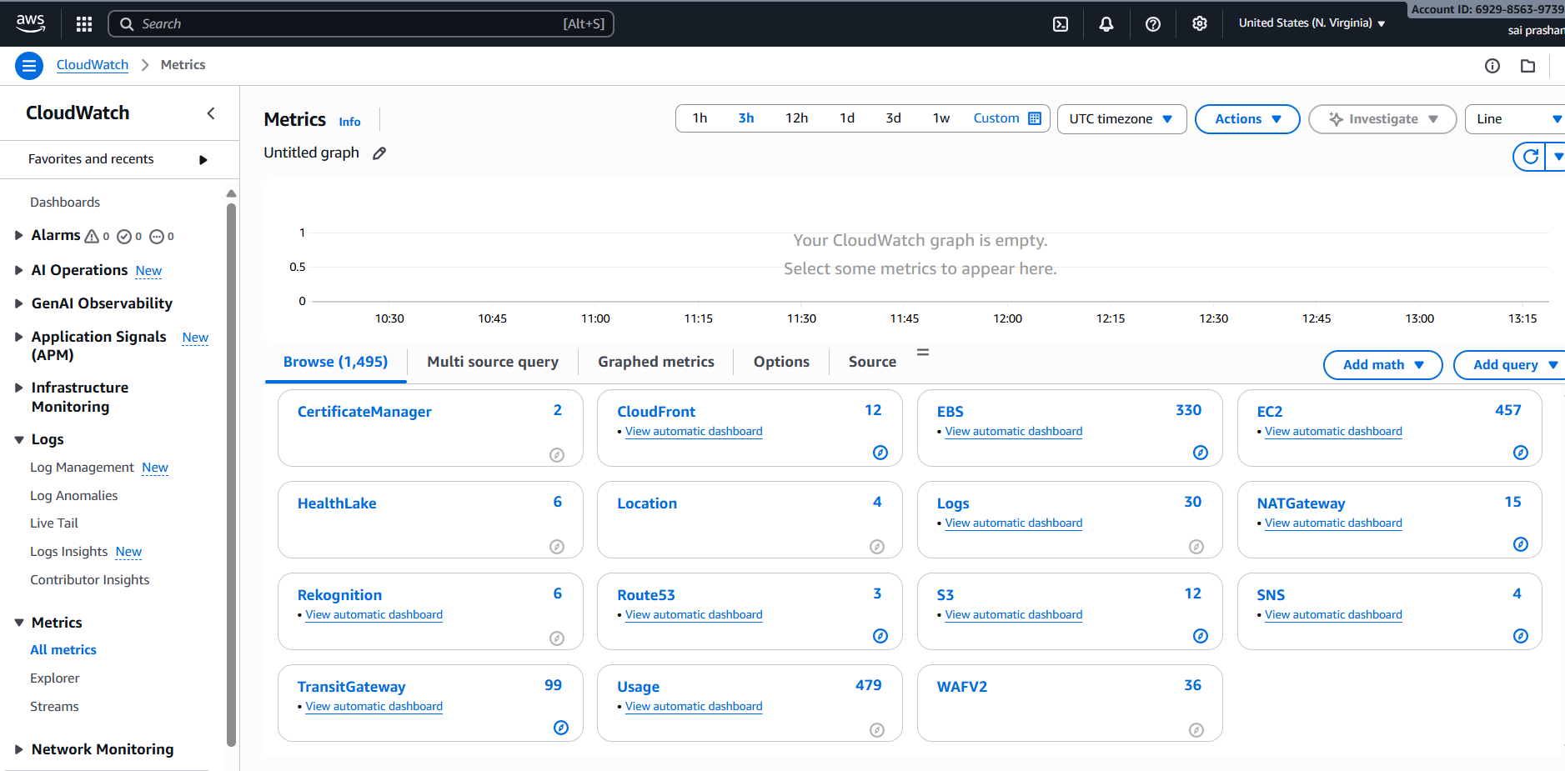

now select the cpu

now in actions---click on add to dashboard

to check in ec2

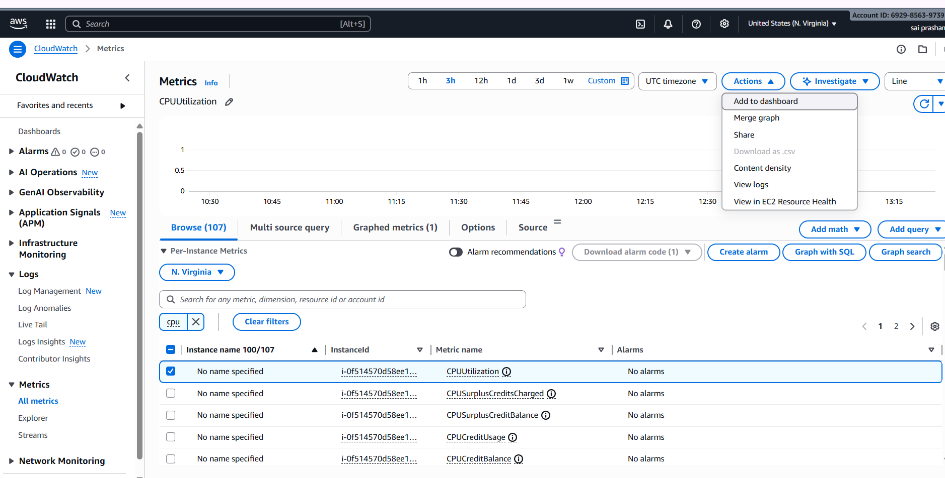

after clicking it u can select existing if there is any dashboard or u can create new one

now select the widget type as number and click on add to dashboard

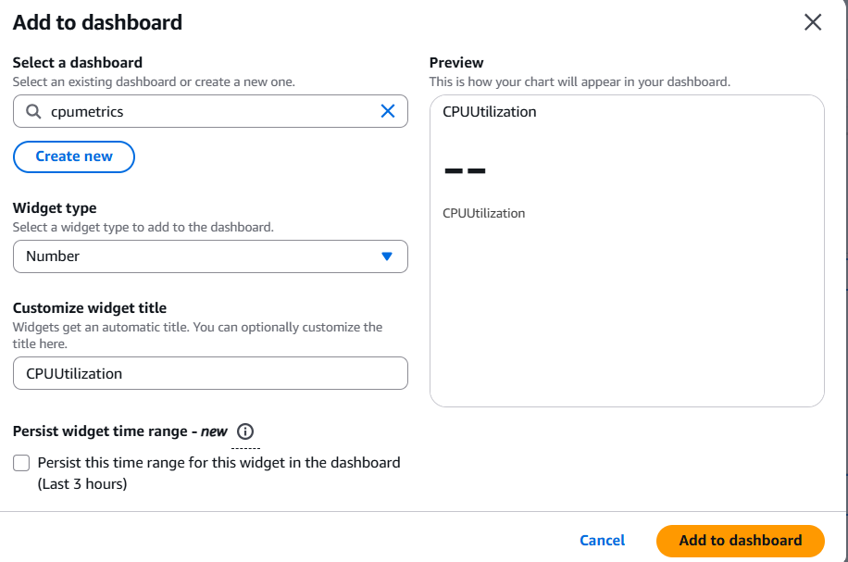

now you can see the CPU utilization in your dashboard

it is 100 % in your ec2 now

here I have checked with different metrics which was connected with my instance

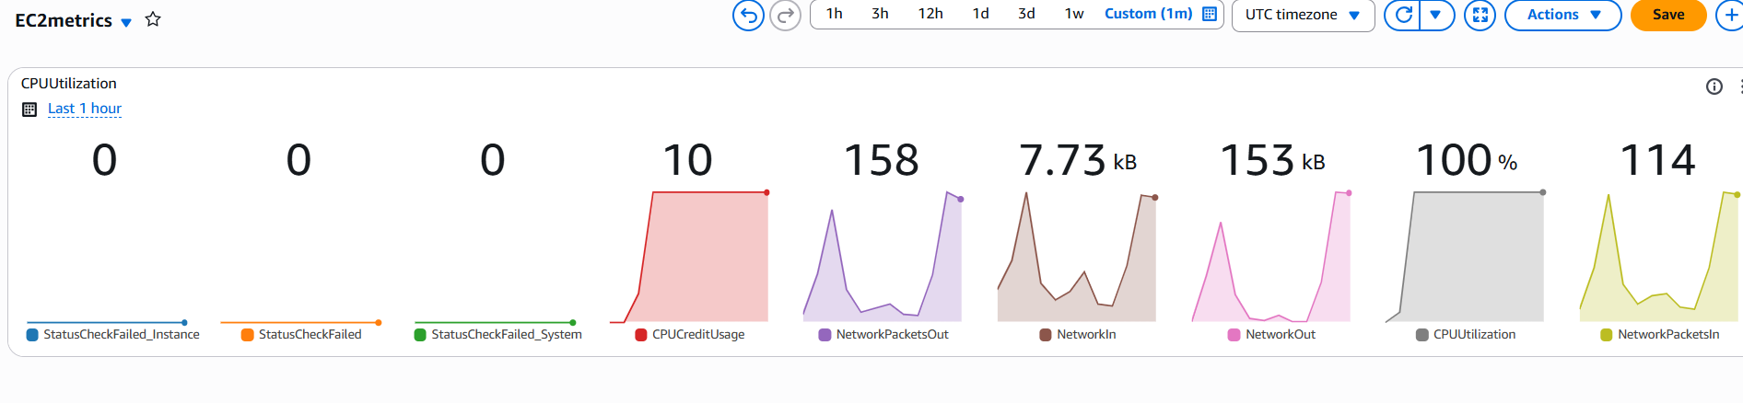

**validation steps:**

now connect the instance and use top command to check the CPU utilization

57 7 has been used

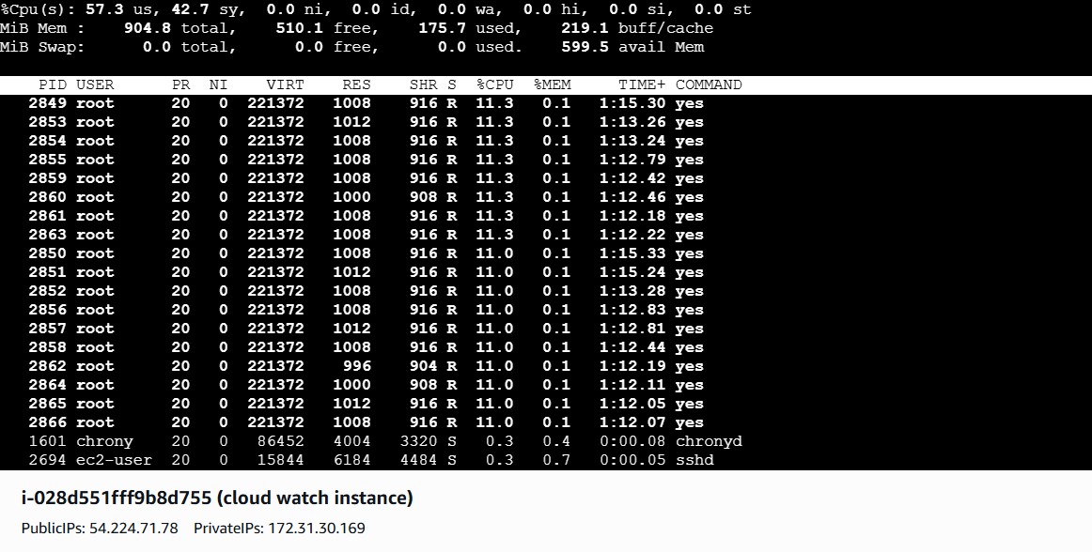

now to check the load of CPU use the command yes > /dev/null &

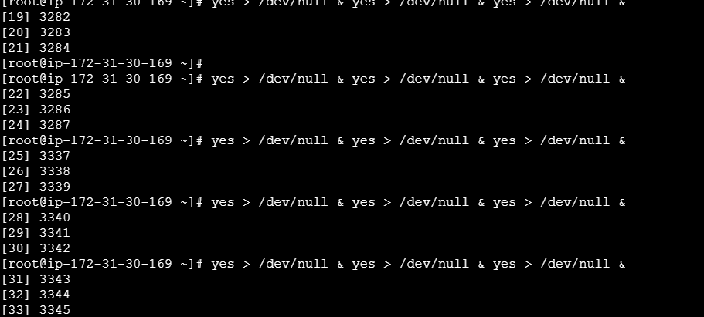

error steps:

getting CPU utilization in number format in dashboard was too late because of latency

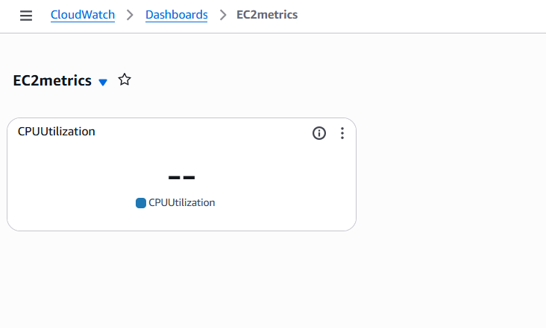

conclusion: now we can see the CPU utilization in number format

1. **title: Create one alarm to send alert to email if the CPU utilization is more than 70 percent.**

**objective:** if CPU utilization is more than 70 percent, we need to get an alarm notification like an alert to email. once if we received, we can solve it

**prerequisites:**

email id

ec2

cloud watch

**step by step process:**

first go to cloud watch – go to alarm – create alarm

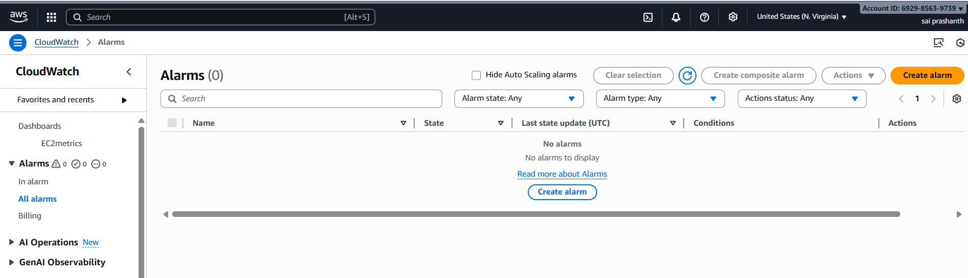

after clicking it—select the metric …

here I have searched through instance id and selected CPU utilization

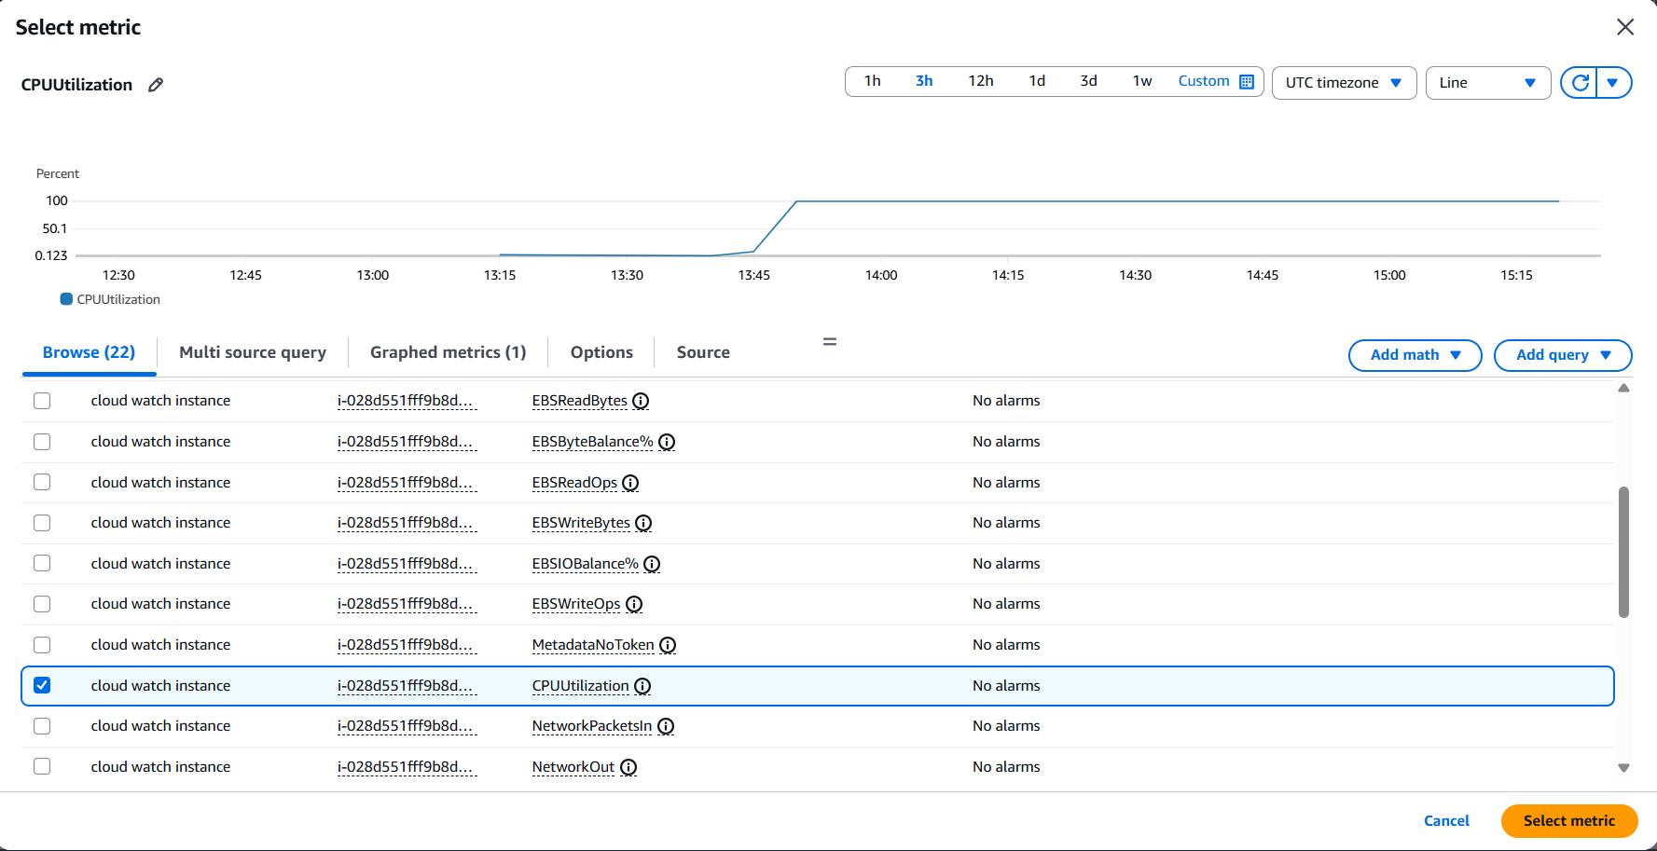

check the metric name and instance id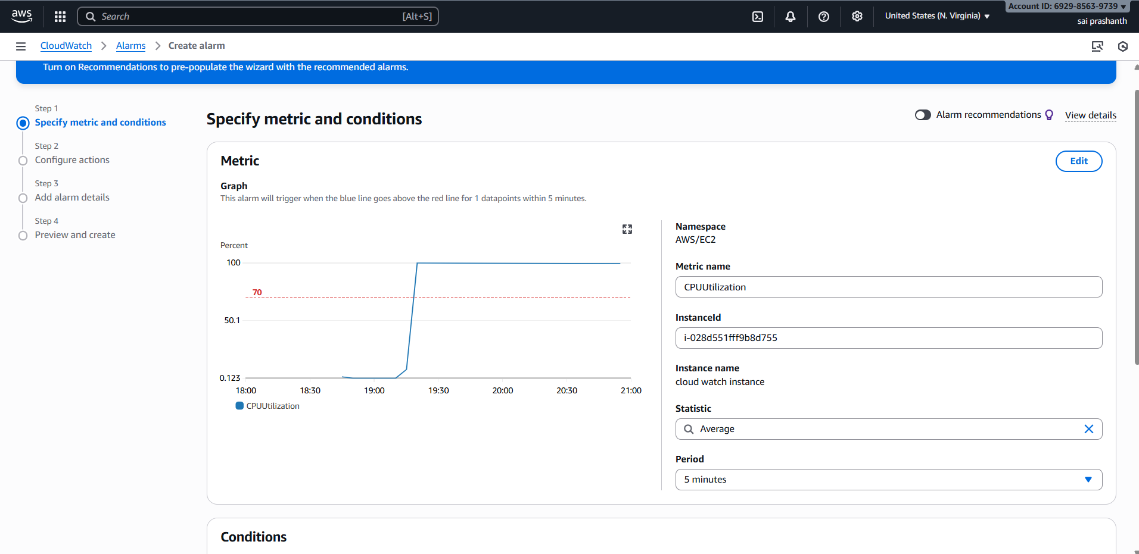

and now in conditions add 70 in threshold u need to select greater than because task is about greater than 70%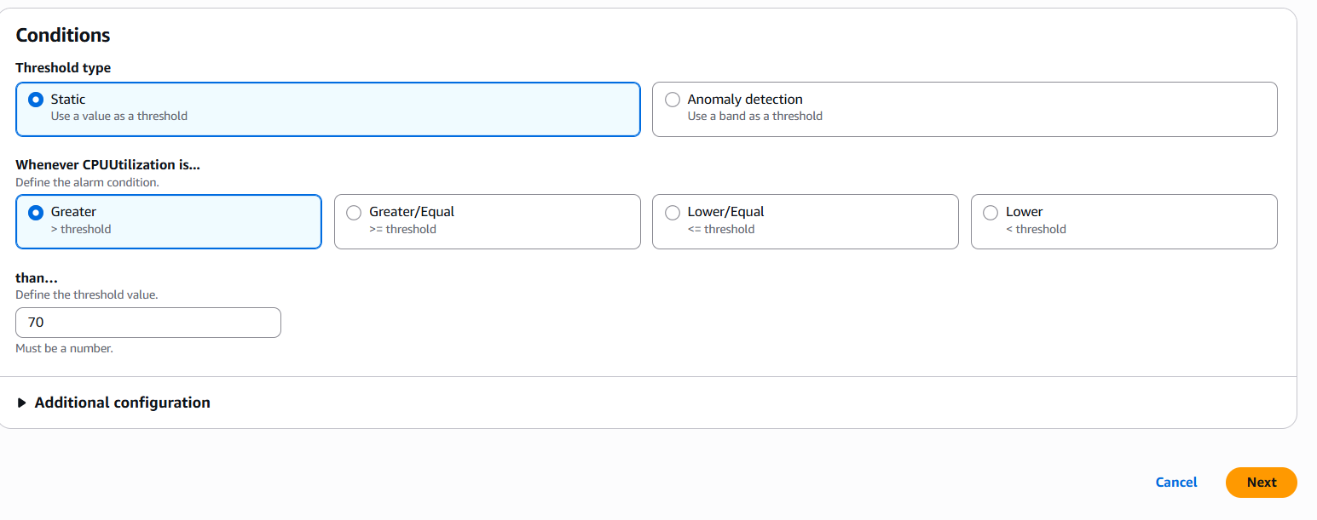

after clicking next select notification it’s already existed u need to select that cloud trail

and verify your email

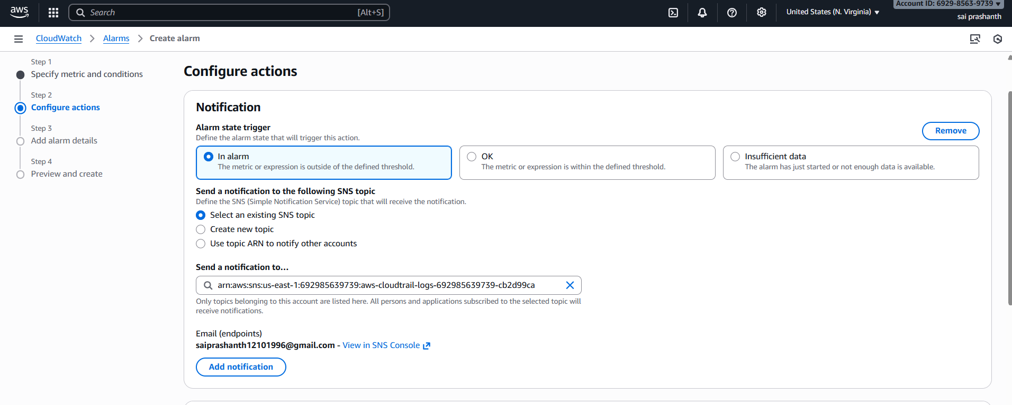

after clicking next add your alarm name and click nextafetr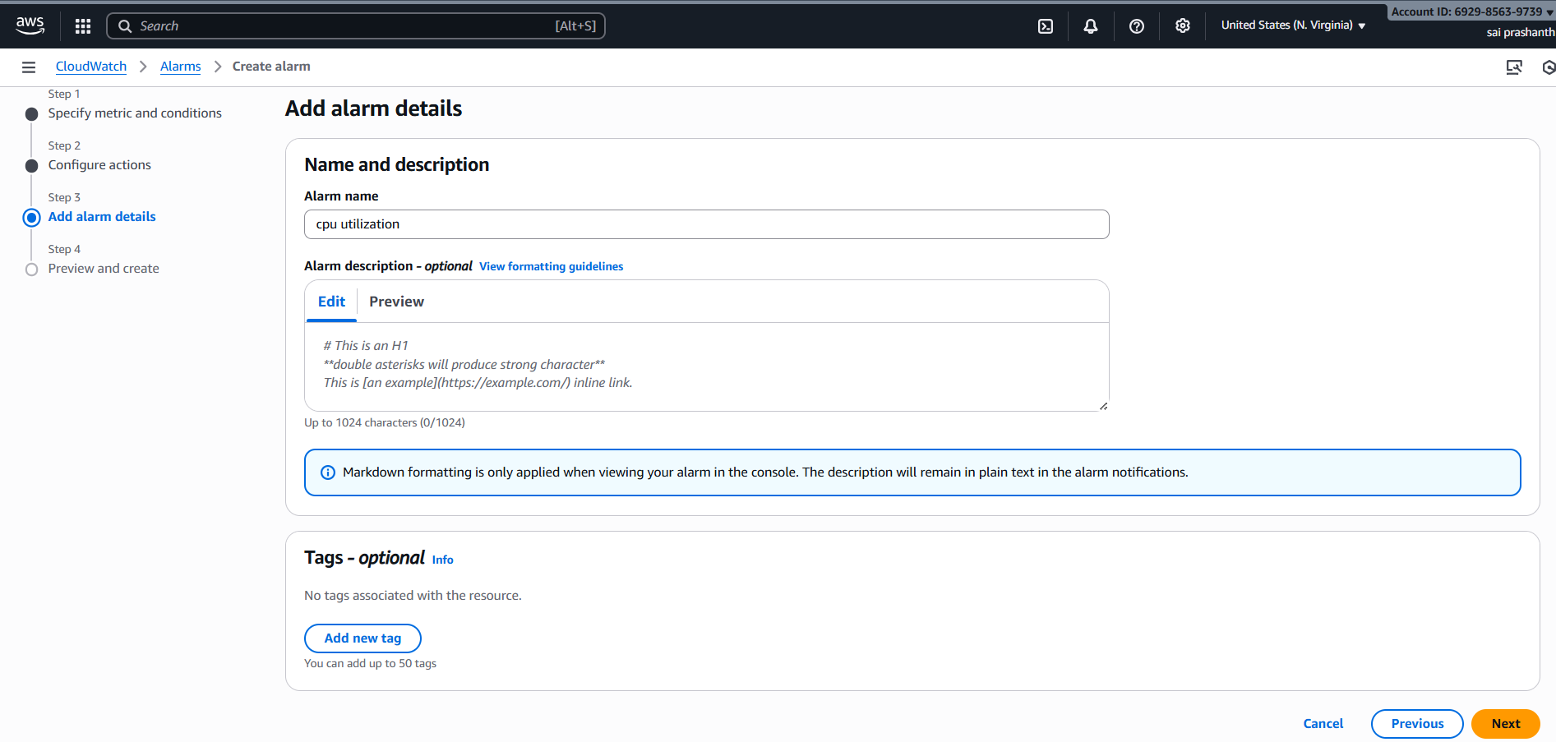

after licking next---click on create alarm

now you can see alarm has been created successfully

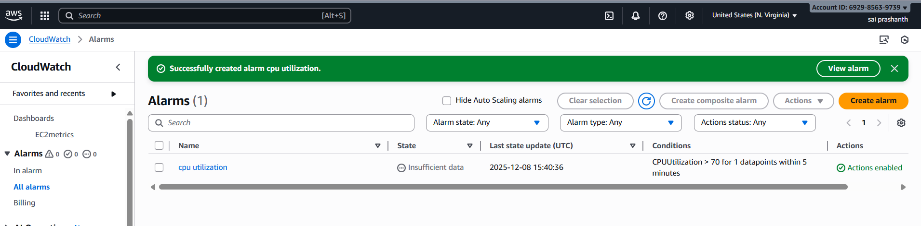

validation steps :

now you can verify the alarm by clicking on all alarms

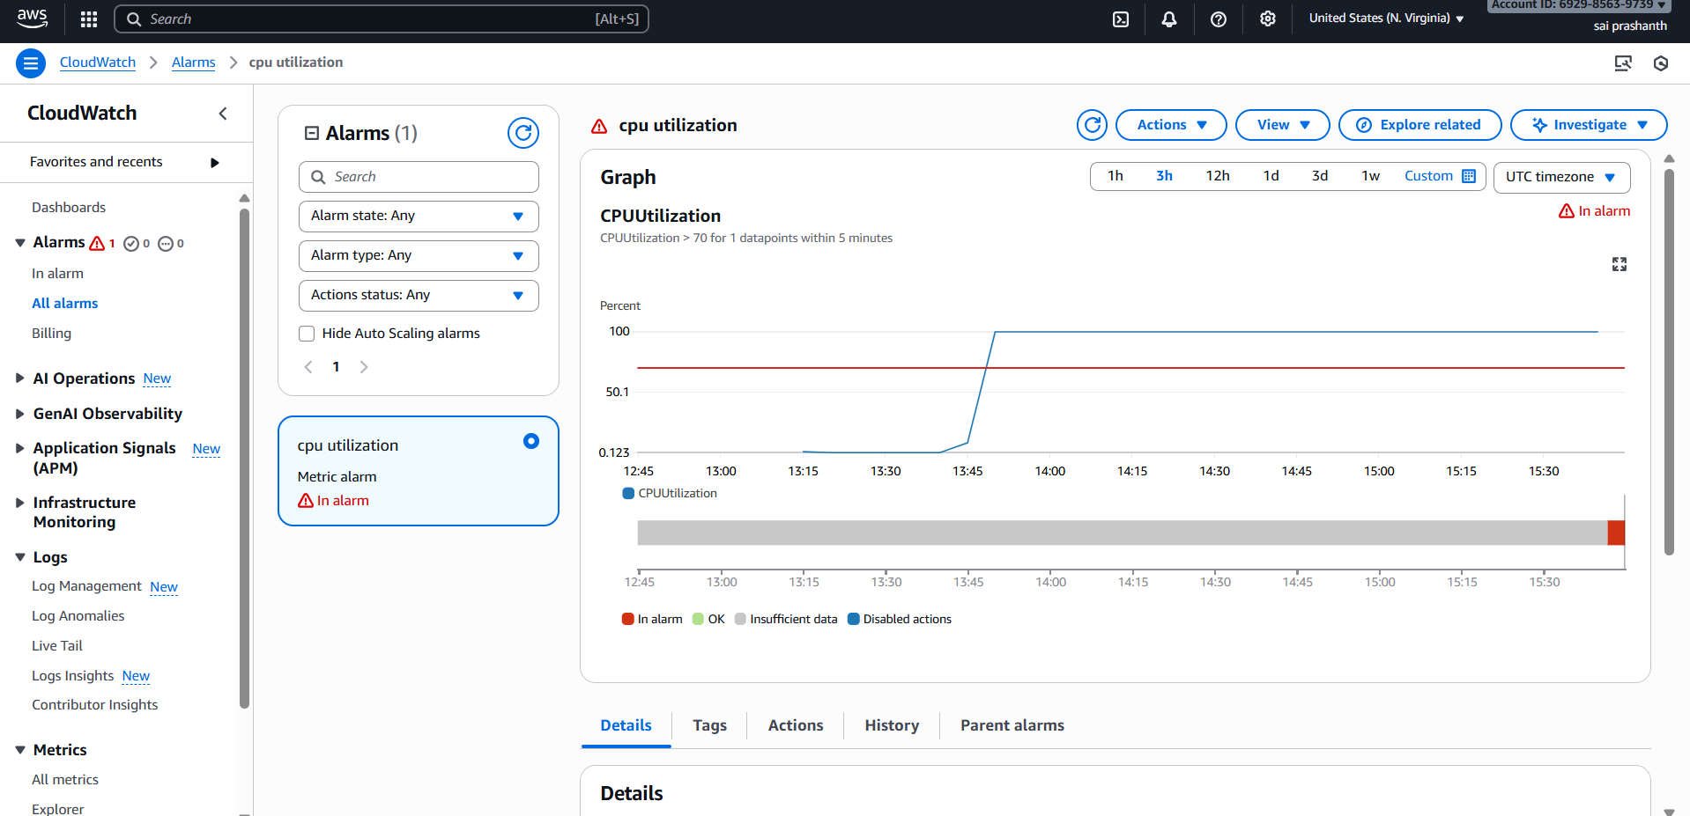

now once you open email and check the alert received or not

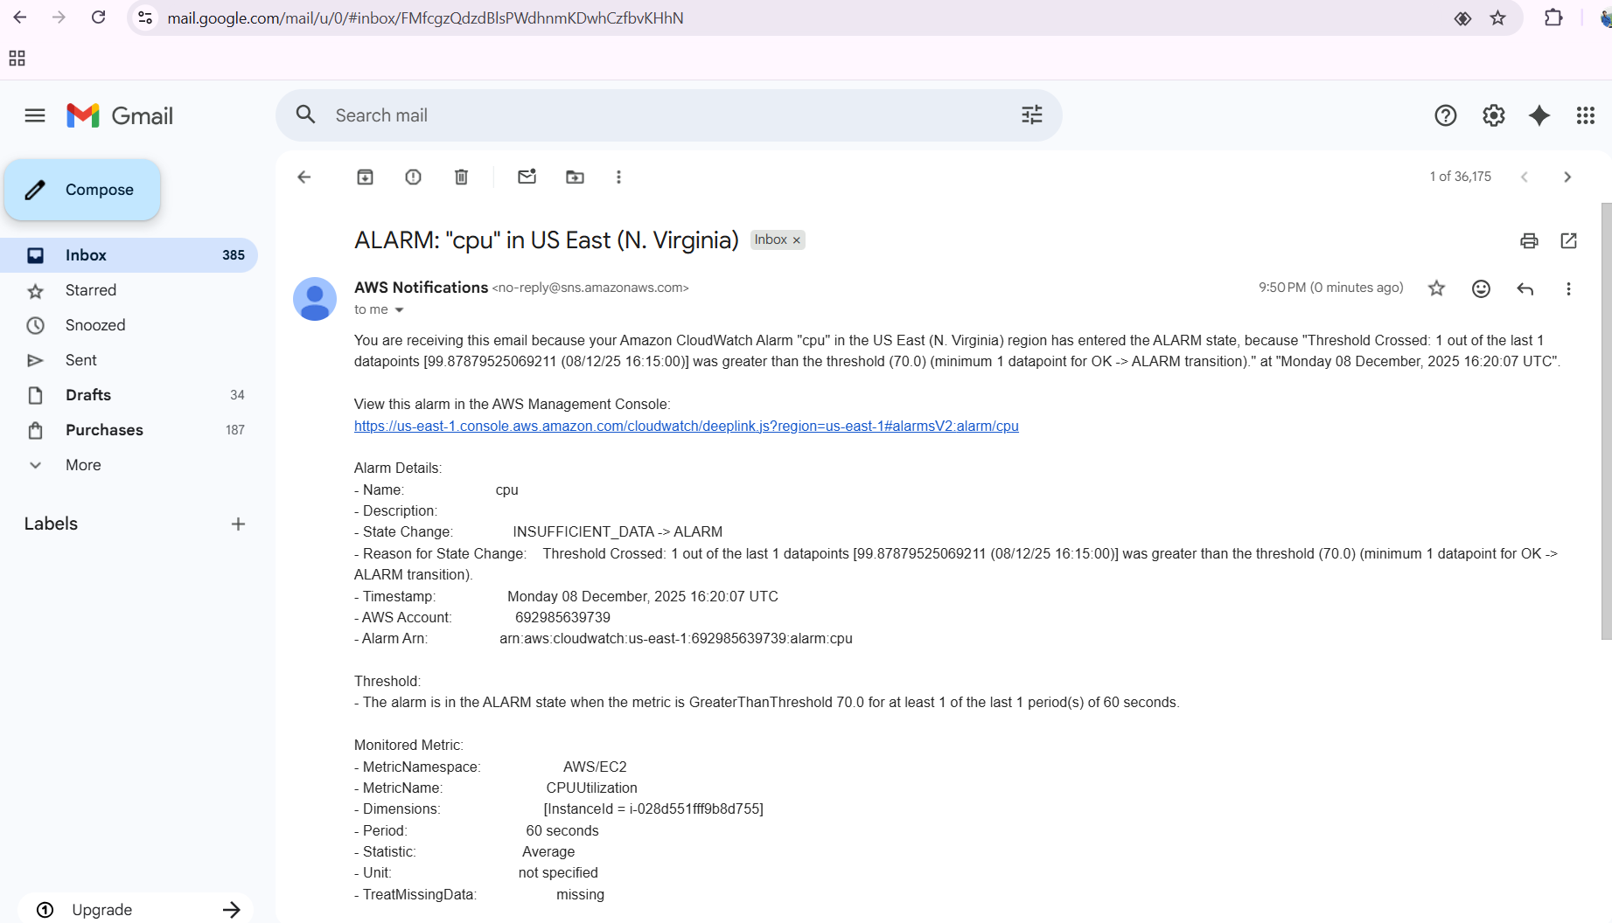

conclusion: this is the way of getting email notification when you set an alarm if it is getting more than 70 %

1. **title: Create Dashboard and monitor tomcat service whether it is running or not and send the alert**

**objective:** we need to monitor tomcat service whether it is running or not and we need to send the alert.

**prerequisites:**

install of tomcat

java

ec2

CloudWatch

sns

alarm

bash script

**step by step process:**

firstly, switched to root user and installed java

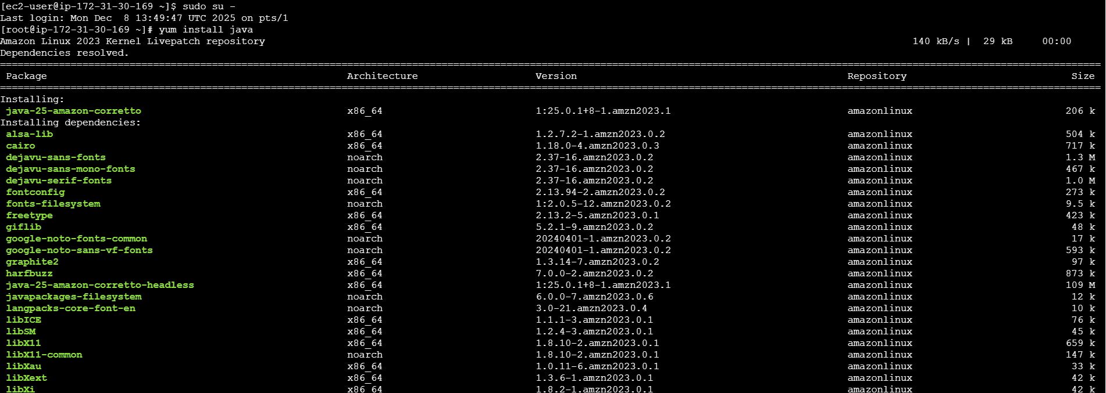

after installing java need to install

same process how we followed before

search in browser---tomcat select one version—in tar.gz link—copy the link address

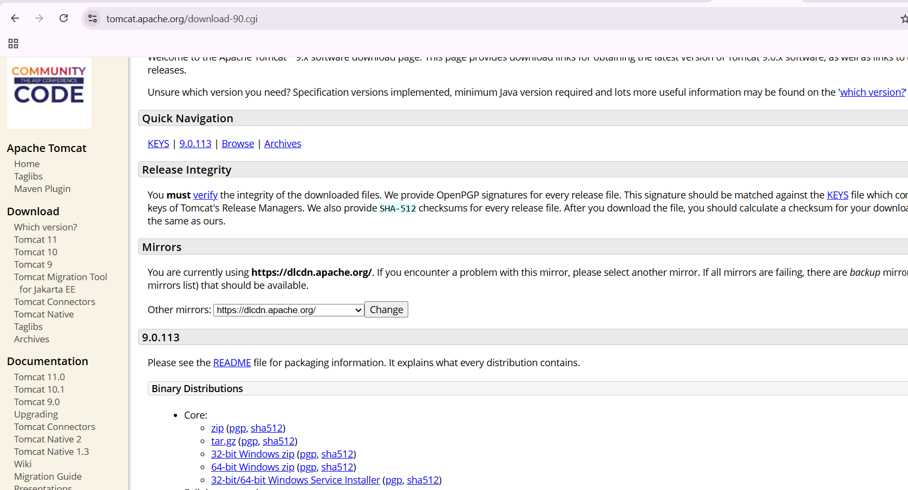

now come to your terminal and use wget and paste the link

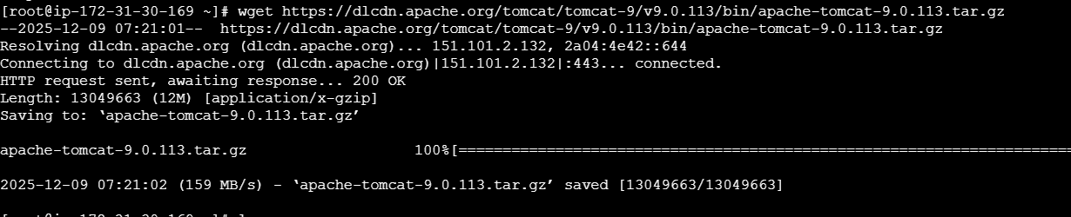

once it has been installed extract the fille by using tar xvf

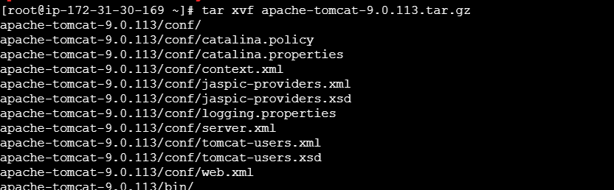

after extracting got to the first link and do ls

now go inside bin

use cd bin/

now use ./start.up.sh

u can see tomcat has been installed and running

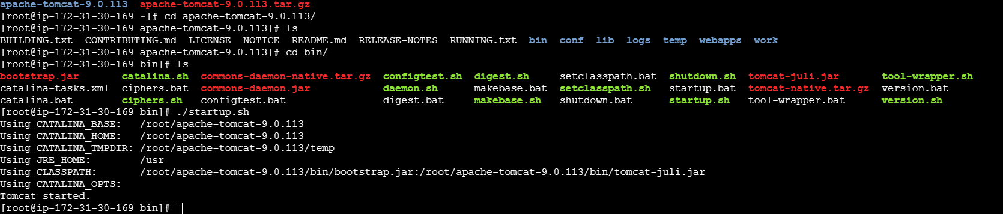

to check in browser, copy the public ip with port number 8080

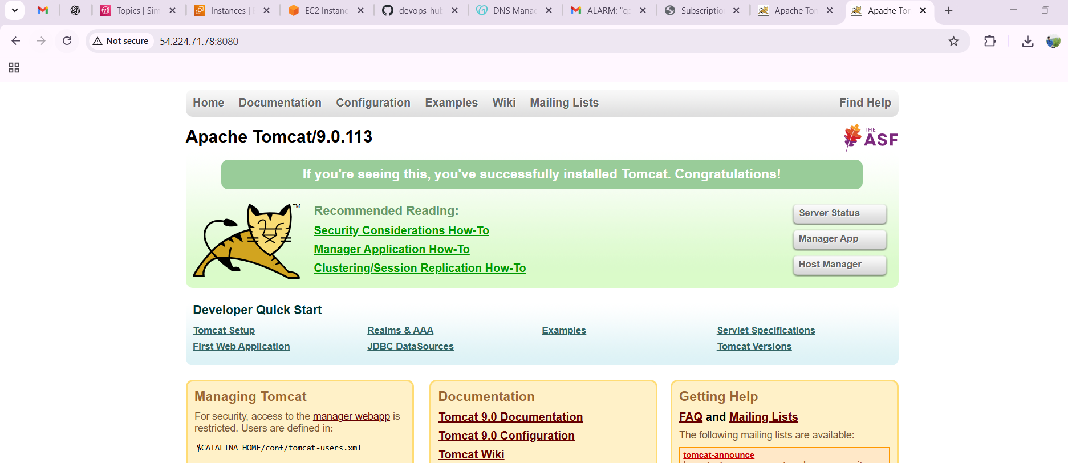

now we need to run the script to to monitor tomcat service status and push to cloud watch

vi monitoring.bash

#!/bin/bash

SERVICE="tomcat"

STATUS=$(systemctl is-active $SERVICE)

if [ "$STATUS" == "active" ]; then

VALUE=1

else

VALUE=0

fi

aws cloudwatch put-metric-data \

--metric-name TomcatStatus \

--namespace "Custom/Tomcat" \

--value $VALUE \

--unit Count \

--region us-east-1

save it

now we need to give permissions

chmod u+x monitoring.bash

./monitoring.bash

if you didn’t get the output you need to do configuration of aws

aws configure—access key—secret key---region—format

now try to execute

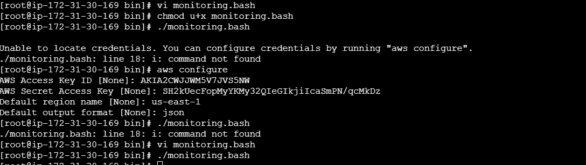

now I installed cronjob

to install use yum install cronie -y

after getting installed we need to run this tomcat service every minute

I have used this command and save it and do restart your crond

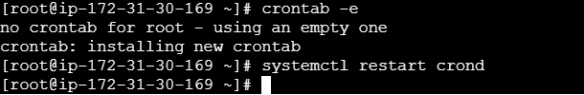

now we need to set up a role in IAM and select AWS service trusted type—select use case EC2

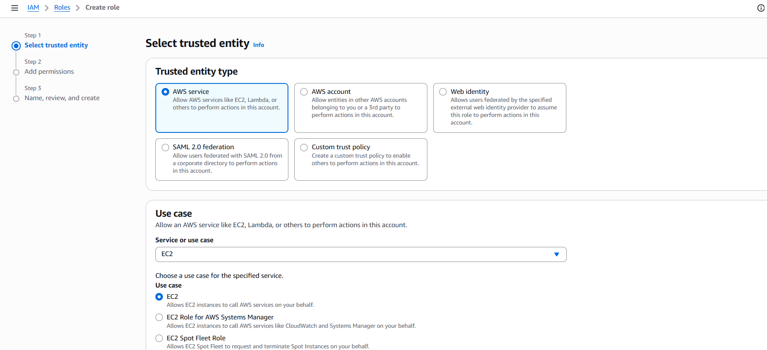

select the permission ec2 read access and ssh managed ec2 policy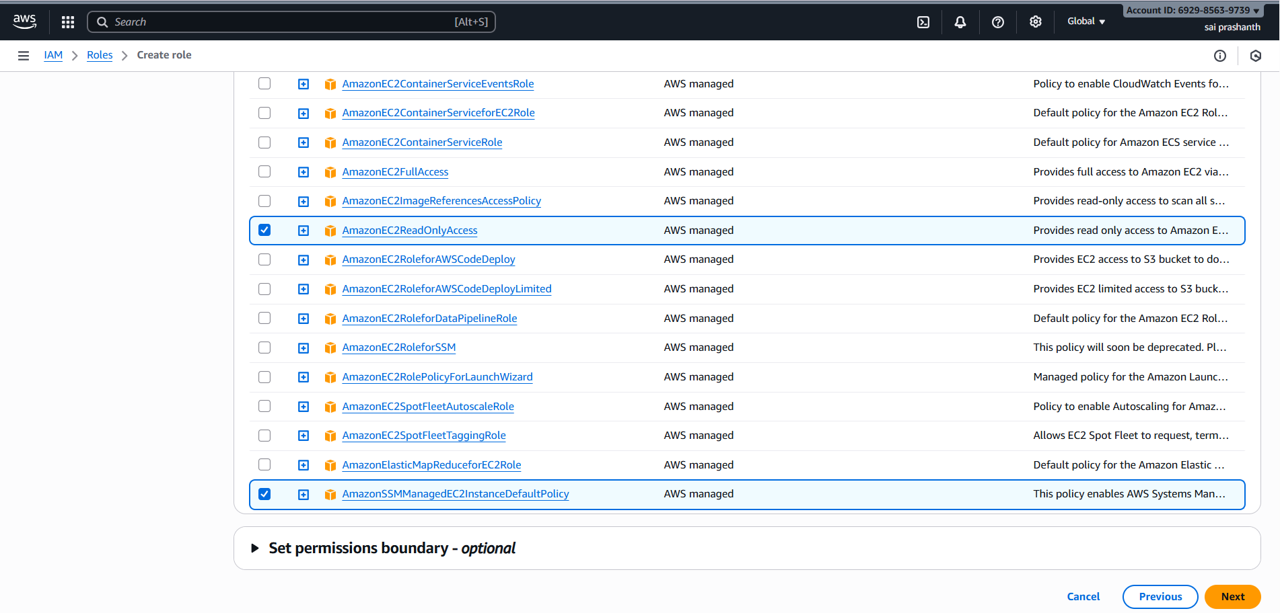

now we need to give a role name and save

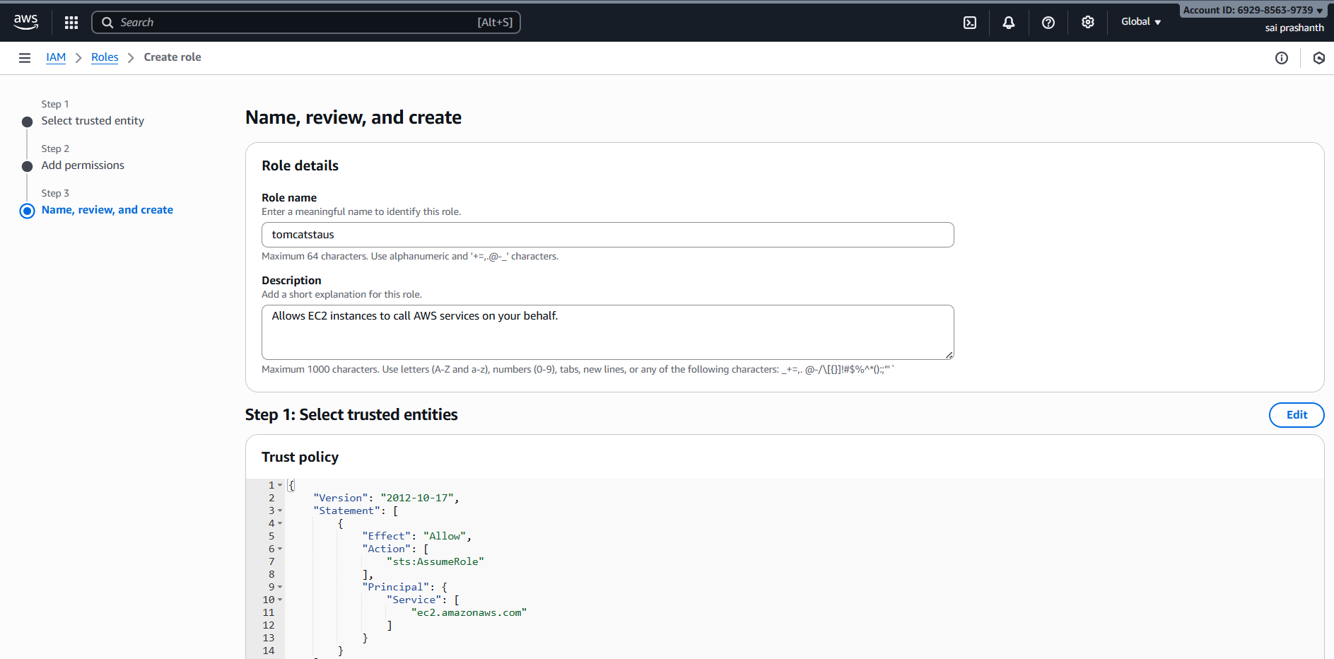

now role has been created successfully

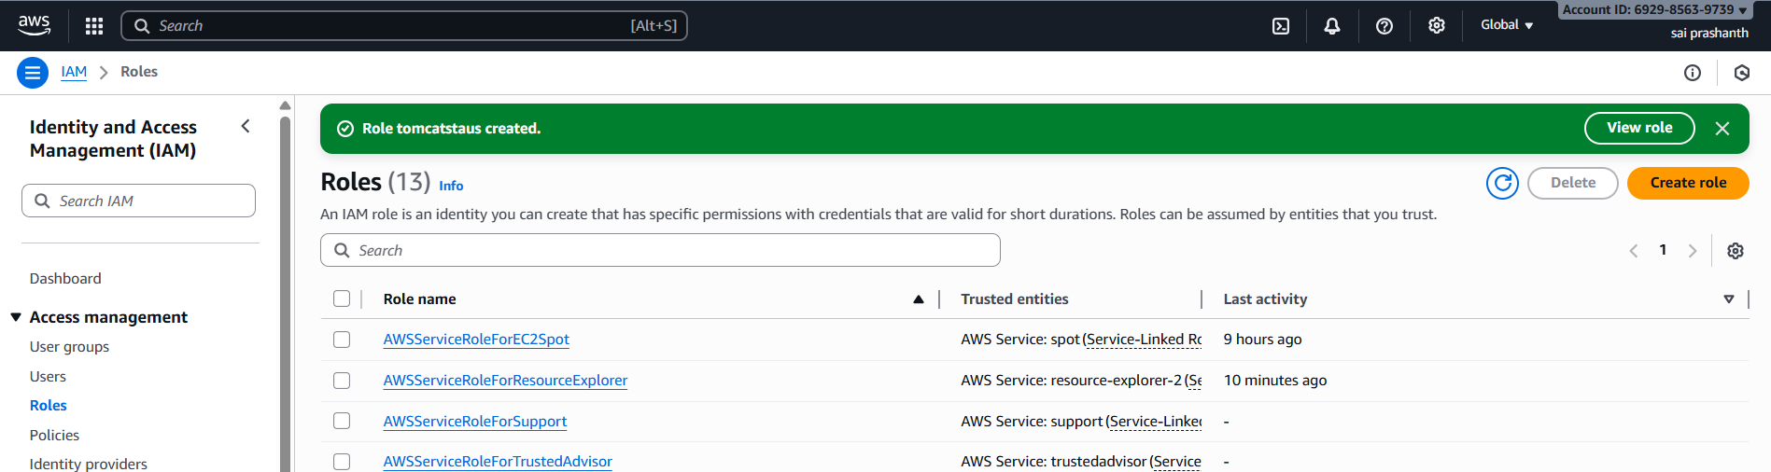

now go to ec2 and modidy the IAM role

your instance—actions—security—modify IAM role

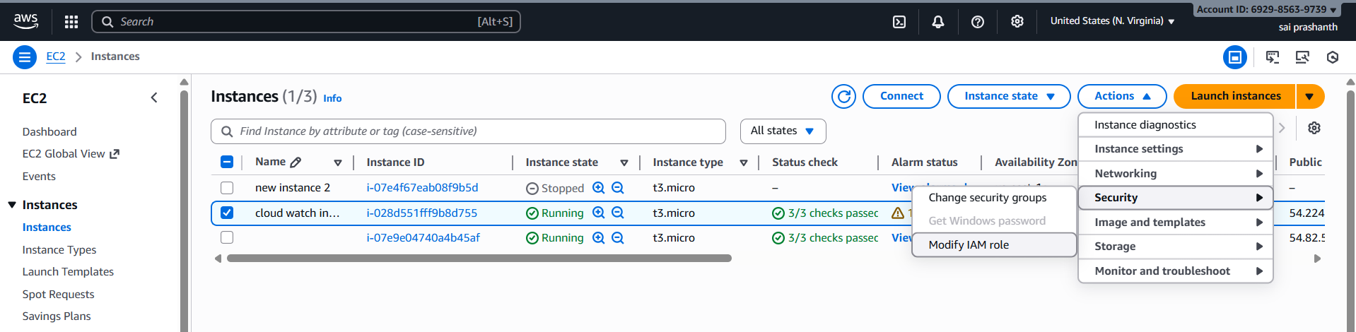

now attach your IAM role tomcat status which you have created

update your iam role

now you can see the attached role to instance

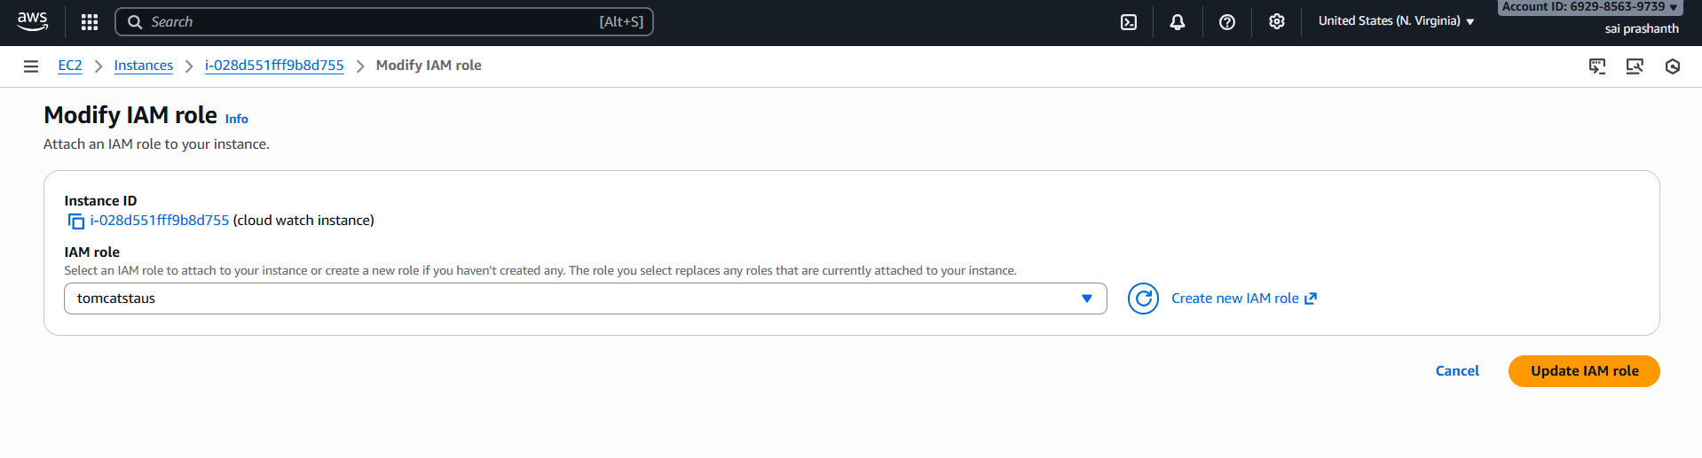

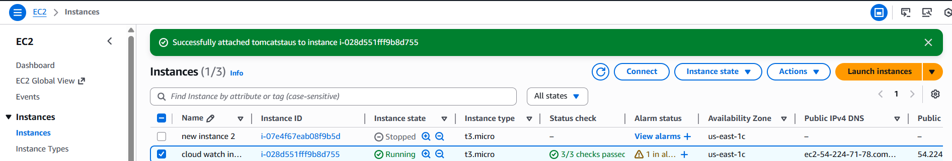

now go to cloud watch and check the dash board

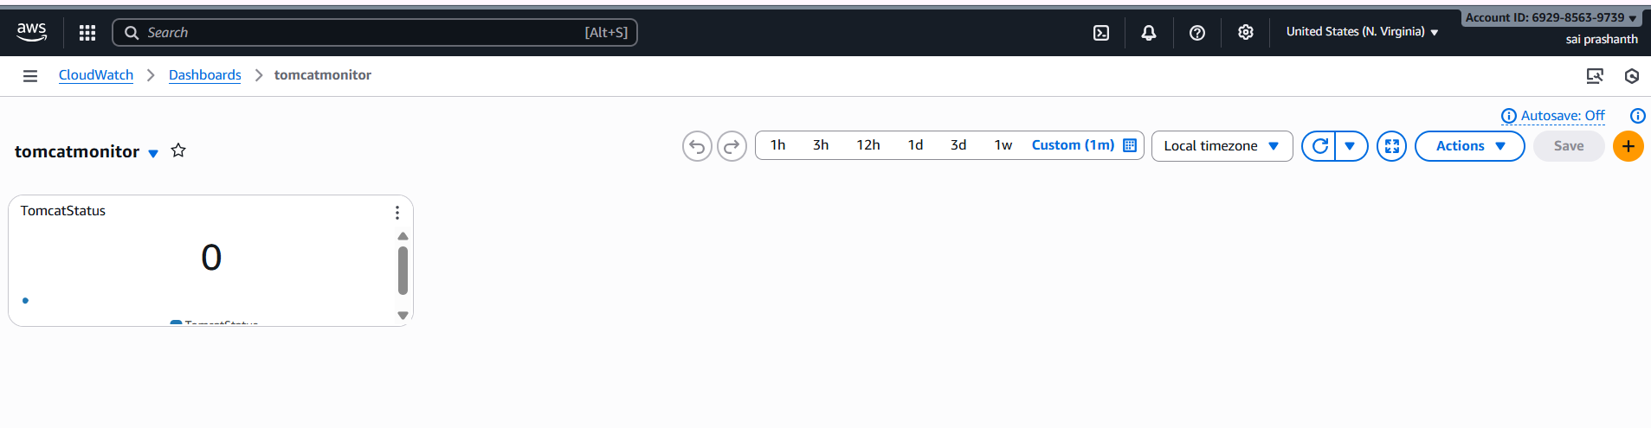

now go to metrics and select tomcat to create an alarm

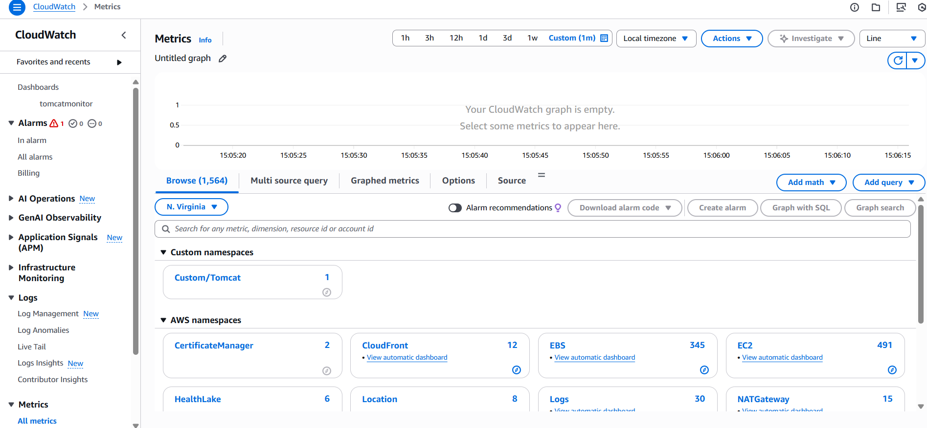

now we need to set an alarm

select the tomcat metrix

conditions select—lower/equal

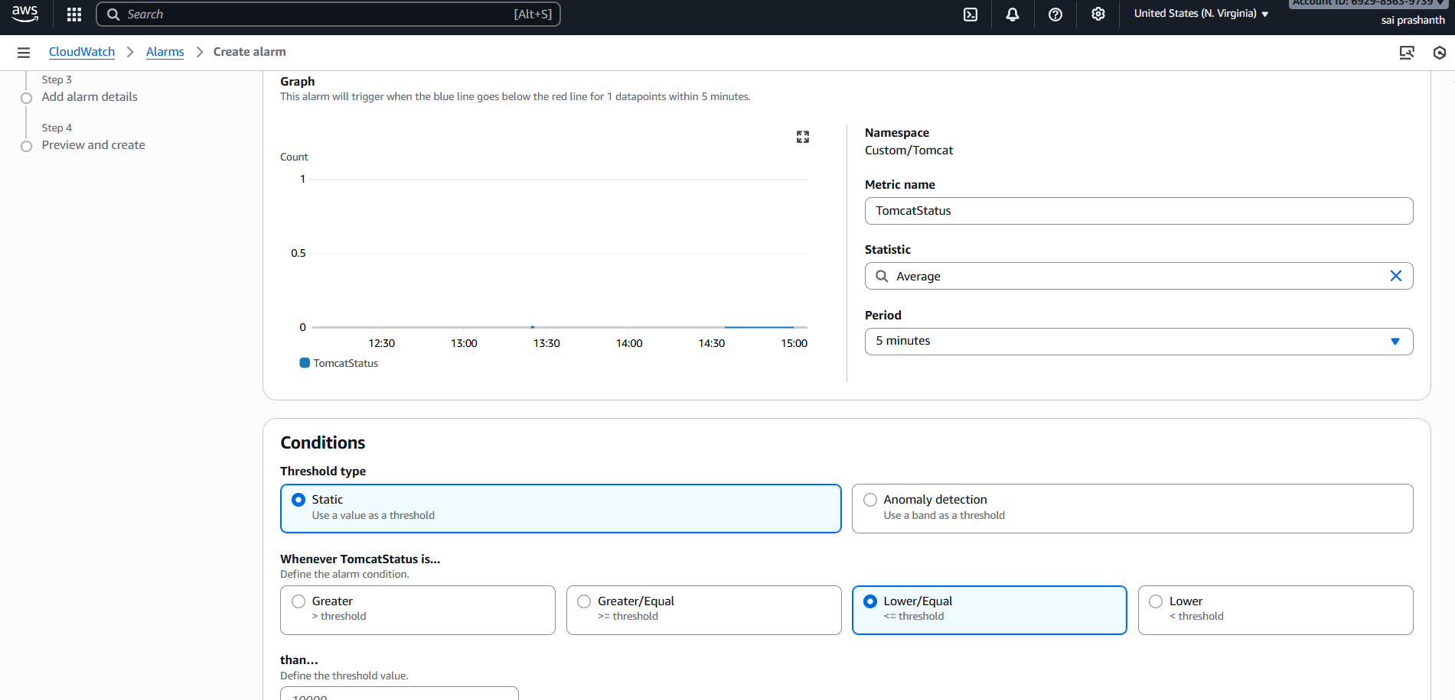

now after clicking next we need to go SNS we need to select existing or create new topic and click on next

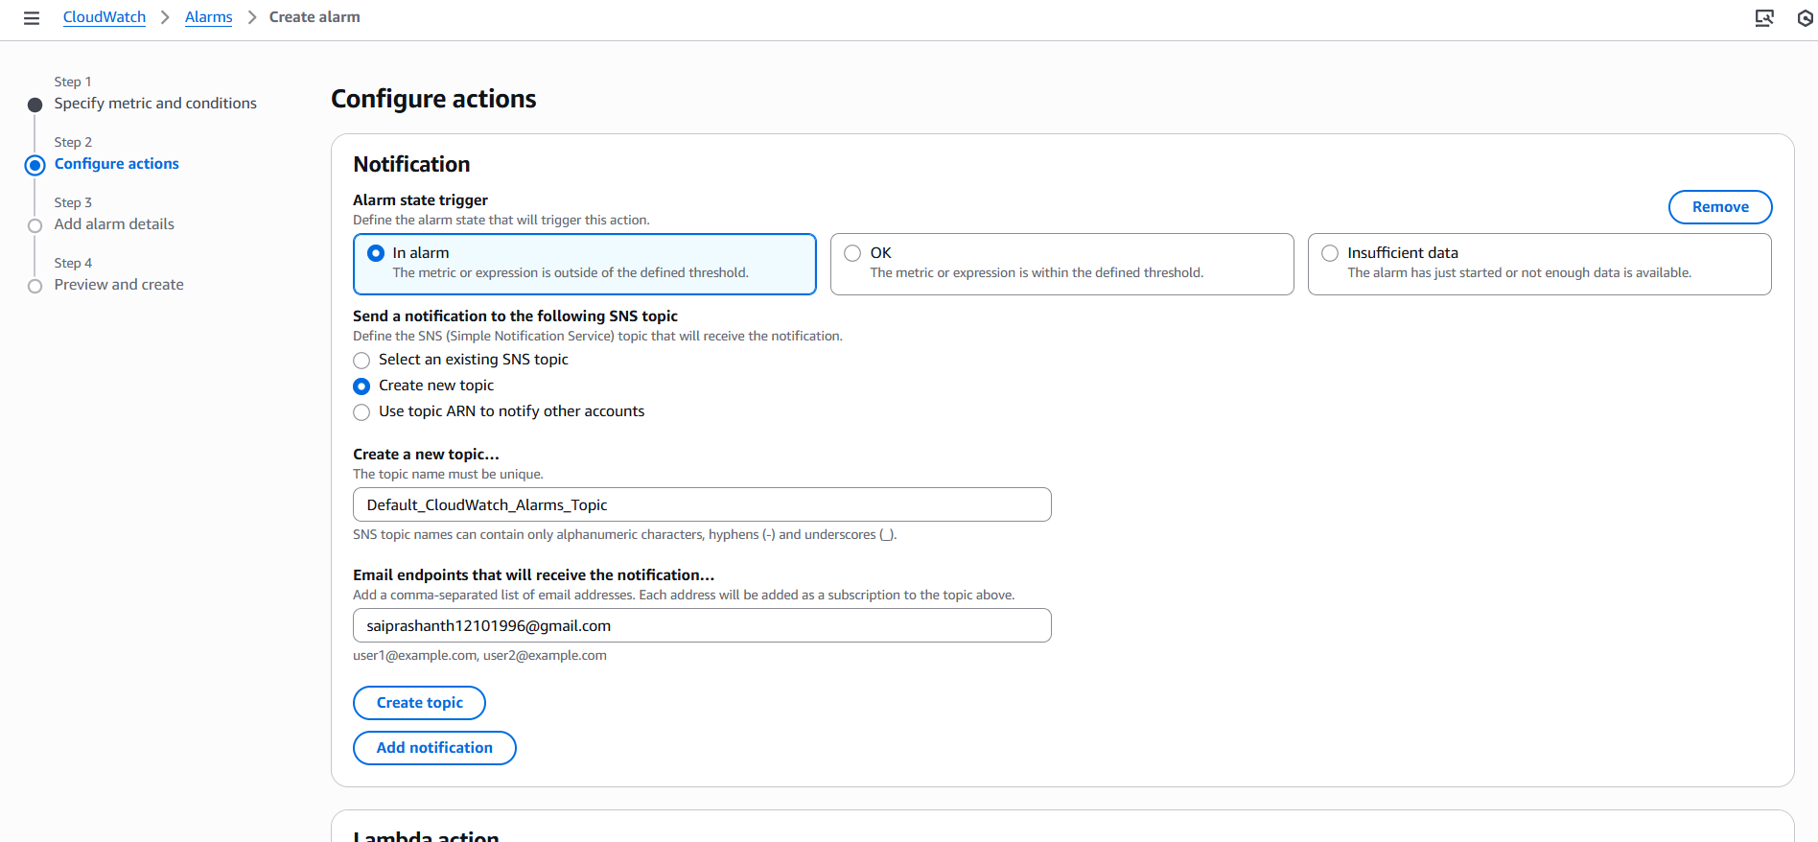

now we need to add alarm name and click on next

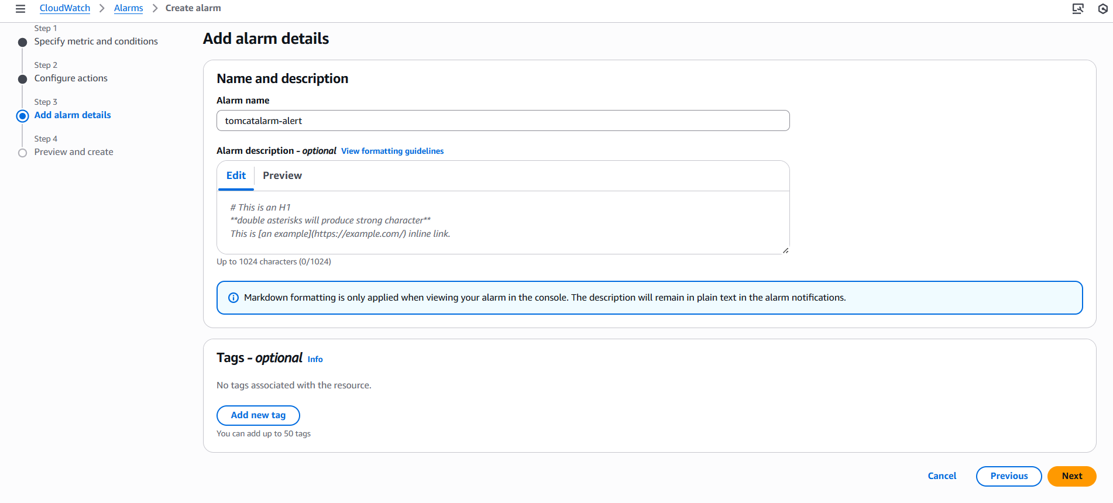

now alarm has been created

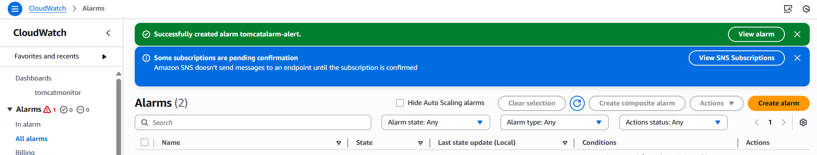

1. **title: Create Dashboard and monitor nginx service to send the alert if nginx is not running**

**objective:** we need to create one dashboard and we need to monitor nginx and we need to receive an alert if nginx is not running.

**prerequisites:**

nginx

CloudWatch

SNS

alarm

**step by step process:**

first go to aws console

we need to create one instance

now same old process

we need to install nginx

yum install nginx -y

sudo systemctl start nginx

sudo systemctl status nginx

next we need to create cronjob

we need to start and enable crond

**bash script**

#!/bin/bash

REGION="us-east-1"

NAMESPACE="Custom/Nginx"

METRIC_NAME="nginx_status"

SERVICE_NAME="nginx"

AWS_CLI="/usr/bin/aws"

TOKEN=$(curl -s -X PUT "http://169.254.169.254/latest/api/token" \

-H "X-aws-ec2-metadata-token-ttl-seconds: 21600")

INSTANCE_ID=$(curl -s -H "X-aws-ec2-metadata-token: $TOKEN" \

http://169.254.169.254/latest/meta-data/instance-id)

if systemctl is-active --quiet nginx; then

STATUS=1

else

STATUS=0

fi

$AWS_CLI cloudwatch put-metric-data \

--region "$REGION" \

--namespace "$NAMESPACE" \

--metric-name "$METRIC_NAME" \

--value "$STATUS" \

--dimensions Name=InstanceId,Value="$INSTANCE_ID"

and created cronjob with command

crontab -e

* * * * * /home/ec2-user/nginx.sh >> /tmp/nginx_cron.log 2>&1

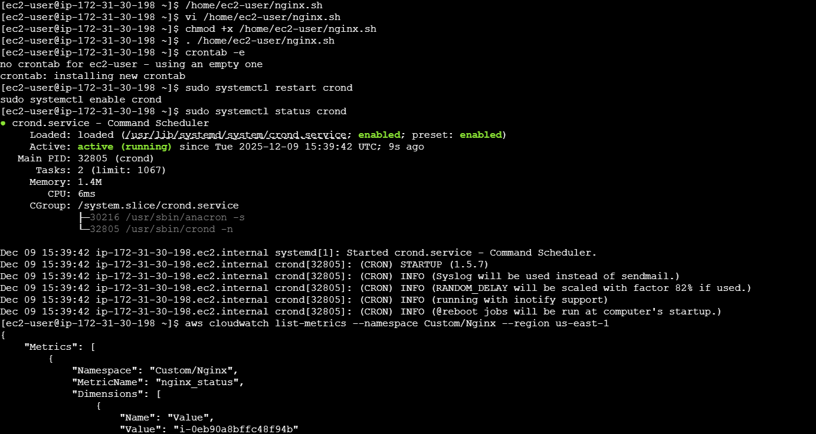

now we need to go to cloud watch

and check the dashboard

and set the time limit to 1 minute

if it displaying as 1 your ngnix is running

if you stop the nginx service

it becomes 0

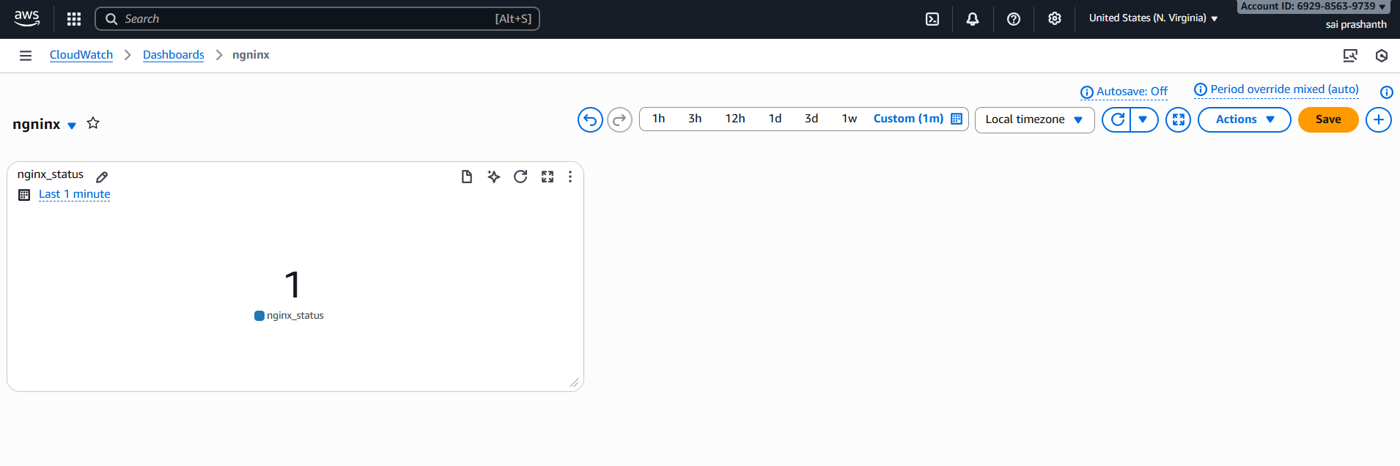

if we stop the nginx it becomes 0

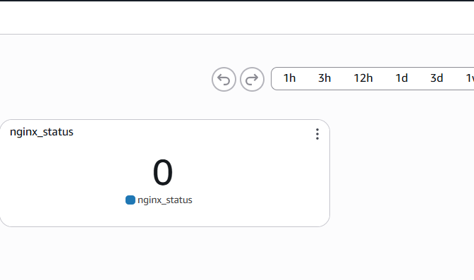

then we need to receive an alert to email

now we need to set alarm notification

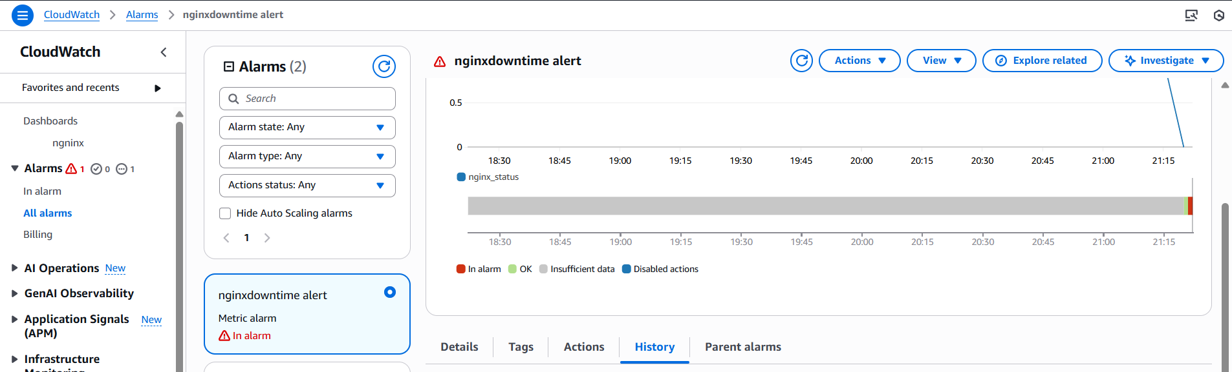

validation: now you need to receive an email

